AGREEMENT

BETWEEN

GARDEN GROVE UNIFIED
SCHOOL DISTRICT



AND

GARDEN GROVE EDUCATION ASSOCIATION/CTA/NEA



JULY 1, 2025 – JUNE 30, 2026

GARDEN GROVE UNIFIED SCHOOL DISTRICT

ACKNOWLDGEMENTS

GGUSD BOARD OF EDUCATION
Bob Harden
Lan Quoc Nguyen, Esq.
Walter Muneton
Dina L. Nguyen
Teri Rocco

Gabriela Mafi, Ed.D., Superintendent

GGEA EXECUTIVE BOARD MEMBERS

Sarah Held, President
Nicole Ciccarelli, 1st Vice President
Donny Terranove, 2nd Vice President
Raquel Manriquez, Secretary
Theodore Vo, Treasurer

GGEA/CTA/NEA NEGOTIATING TEAM

Tamra Wood
David Austin
Joe Miller
Stacey Carter
Michelle Muckey
Tanya Schumacher
Paul Kim

GARDEN GROVE UNIFIED SCHOOL DISTRICT
GARDEN GROVE EDUCATION ASSOCIATION

TABLE OF CONTENTS

Article |  |  |  | Page
 | 1 | Agreement |  |  | 1
 | 2 | Recognition |  |  | 1
 | 3 | Definitions |  |  | 3
 | 4 | Hours of Employment |  |  | 4
 | 5 | Grievance Procedures |  |  | 12
 | 6 | Safety |  |  | 16
 | 7 | Evaluation Procedures |  |  | 17
 | 8 | Peer Assistance and Review (PAR) |  |  | 21
 | 9 | Class Size |  |  | 23
 | 10 | Transfer Procedures |  |  | 24
 | 11 | Leaves |  |  | 27
 | 12 | Wages |  |  | 45
 | 13 | Health and Welfare Benefits |  |  | 60
 | 14 | Association Rights |  |  | 68
 | 15 | Junior Reserve Officer Training Corps |  |  | 71
 | 16 | Savings |  |  | 73
 | 17 | Completion |  |  | 73
 | 18 | Professional Growth |  |  | 74
 |  | Salary Schedules |  |  | 76
 |  | Evaluation Procedures |  |  | 78
 |  | Grievance Report |  |  | 84
 |  | Calendars |  |  | 85
 |  | Memorandum of Understanding |  |  | 91
 |  |  | 2026-2027 Class Size |  |  | 93
 |  |  | 2025-2026 Class Size |  |  | 94
 |  |  | Stipend Approval Process |  |  | 95
 |  |  | Dual/Concurrent Enrollment |  |  | 96
 |  |  | Extra Duty Pay State Preschool Teachers |  |  | 97

 |  | Special Ed. Class Size & Release Time M/M & M/S |  | 98
 |  | M/M Special Ed. Inclusion |  | 99
 |  | Compensation for Teachers During Substitute Shortage |  | 100
 |  | Differential Pay Adult Education and General Education Preschool Teachers Class Size |  | 101
 |  | 9th Grade On-Track Program |  | 102
 |  | Seven Period Assignment at Fitz Intermediate |  | 103
 |  | Release Day/Substitute Day for Site Repairs |  | 104
 |  | Article 12: CPR/First Aid Super Week Offering |  | 105
 |  | Community School Teacher Coaches and Community School Design team member |  | 106
 | Side Letters of Agreement |  | 107
 |  | On-Line Teachers |  | 109
 |  | Credit Recovery |  | 110
 |  | Consult Procedure |  | 111
 |  | Job Sharing |  | 112
 |  | Special Education |  | 113
 |  | Intramural Sports |  | 114
 |  | Site Program Coordinator Selection |  | 115
 |  | Association Dues/Fees | 116
 |  | Department Chairperson Election Procedure | 118
 |  | Grade Level Election Procedure | 119
 |  | Peer Assistance and Review Panel | 120
 |  | Adult Education and Duty-Free Breaks | 125
 |  | Preschool Release Days - Data Entry DRDP | 126

ARTICLE 1 – AGREEMENT

1.1 | The Articles and provisions contained herein constitute a bilateral and binding agreement {"Agreement") by and between the Garden Grove Unified School District ("District") and the Garden Grove Education Association/C.T.A./N.E.A. ("Association") an employee organization.
1.2 | The Agreement is entered into pursuant to Chapter 10.7, Sections 3540-3549, of the Government Code ("Act").
1.3 | The Agreement shall remain in full force and effect from July 1, 2025 - June 30, 2026.
ARTICLE 2 – RECOGNITION

2.1 | The District recognizes the Garden Grove Education Association as the exclusive representative as defined in Section 3540.1 (e) of the Government Code. The exclusive representative shall represent that unit of employees as described below.
All certificated employees not excluded by Section 2.2 of this document, who are regular, full-time, permanent, or probationary employees and are in the following positions:

- Teachers
- Educational Specialists
- Librarians
- Nurses
- Temporary Teacher as defined in Education Code Section 44920
- Optional Part-Time Teacher as identified in 12.7 of this contract
- Job Share Teacher as identified in 12.9 of this contract
- Teachers and Nurses with Categorical Contracts
- Pre-School Teachers
- Pre-School Special Education Teachers
- Adult Education Teachers
- Junior Reserve Officer Training Corps Instructors

Employees whose assignments are partially in one position and partially in another shall be assigned to the Association's unit of employees if half or more of their assignments is one of the positions listed above.

2.2 | Excluded from this unit are: substitutes, management and confidential employees as designated below, employees who are in the Guidance Unit who are listed below, and any other employees not specifically included above.  Management  Superintendent  Associate Superintendent  Assistant Superintendent  Assistant to the Superintendent  Director  Administrative Services  Vocational Education  Special Education Services  K-6 Instruction  7-12 Instruction  Personnel Services  Employee Relations  Adult Education  K-12 Educational Services  Student Services/Health Services  Principal  High School  Continuation High School  Intermediate School  Elementary School  Adult Education  Assistant Principal  High School  Continuation High School  Adult School  Intermediate School  Elementary School  Coordinator  Categorical Programs  Child Welfare and Attendance  Fine Arts  Research, Testing, and Evaluation  Special Education  Supervisor  Media and Technology Services  Gifted and Talented Education – GATE  Child Development Programs  Specialist  LEP Student Services  Instructional Specialist  Confidential  Accountant  Administrative Secretary  Fiscal Services Coordinator  Personnel Analyst  Personnel Secretary  Position Control Technician  Secretary to the Superintendent  Guidance Unit  Audiologists  Counselors  Psychologists  School Social Workers I & II  Speech and Language Pathologists
2.3 | Both parties to this Agreement must agree on the recognition status (for the purposes of representation) of any newly created position.
ARTICLE 3 – DEFINITIONS

3.1 | Employee - Employee who is included in the appropriate unit as defined in Article 2 and therefore covered by the terms and provisions of this Agreement.
3.2 | Work Day - A day when schools in the District are in session, excluding Saturdays, Sundays and Summer Session.
3.3 | School Day - The amount of time each day of classes during which students are required to be in school, unless otherwise provided for in this Agreement.
3.4 | Immediate Supervisor - The supervising administrator having immediate jurisdiction over the employee.
3.5 | Board - Board of Education of the Garden Grove Unified School District. It is understood that the Board may discharge its duties by means of authorized officers, representatives, or committees.
3.6 | School District - The term School District shall refer to the Garden Grove Unified School District.
3.7 | Association - Garden Grove Education Association, which is affiliated with the California Teachers' Association and the National Education Association.
3.8 | Association Negotiating Team - Association members chosen to represent the unit in negotiations.
3.9 | Semester - Approximately one-half of the school year; see calendar for specific dates. (Appendix H)
ARTICLE 4 – HOURS OF EMPLOYMENT

4.1 | Employees shall be required to be at their school site not more than thirty (30) minutes before their instructional time begins and not more than fifteen (15) minutes after their instructional time ends. Employees shall be on site outside of the regular instructional time for additional duties and responsibilities which require a unit member to be at the work site. This includes Back to School Night and Open House. Employees participating in District programs, which require them to be elsewhere may leave after their instructional time ends. Preparation periods are considered part of the instructional time. Bargaining unit members shall be entitled to a thirty (30) minute minimum, uninterrupted, duty-free lunch break.
 | 4.1a | Minimum days may be scheduled for any ESEA and/or School Improvement Plan (AB 65) related meetings that cannot be held within the work time as prescribed by Article 4.1, unless those meetings are held during school purchased released time. Nothing in this article (4.1a) shall be construed to prevent the District from continuing its utilization of minimum days.
 | 4.1b | Collaboration - The purpose of collaboration time is for teachers to work together toward the improvement of student achievement. The District and the Association agree that all teachers, TK-12, will collaborate on a regular and ongoing basis. The teachers and administrators will mutually determine the topics for collaboration time. Of the total collaboration meetings, the Principal will determine topics for up to 25% of the meetings based on school-wide needs, with the remainder being mutually determined. Sites shall determine principal collaboration days no later than the first day of each quarter or trimester.
 |  | Collaboration Plans may include:
1. Changing the daily instructional minutes as defined in
Article 4.5 to bank time for shortened Wednesdays.

 |  | 2. Utilizing a portion of the minutes as defined in Article 4.1 to bank time for shortened Wednesdays
3. Utilizing a portion of the hours allocated for staff
meetings as stated in Article 4.

 | 4.1c | The Collaboration Schedule will be mutually developed by site teachers and administrators. It will be approved by the majority of the teachers at each site via anonymous ballot. The ballots will be counted by the site administrator and one teacher designated by the teachers at the site. The schedule will be submitted by April 1 to the Assistant Superintendent of Elementary Education or Secondary Education for approval. No schedule will be approved that results in a reduction of annual instructional minutes. The site teachers and administrators will review the schedule annually. For schools collaborating weekly, four (4) collaboration days shall be used for individual teacher preparation. The scheduling of the days shall be mutually determined by the administrator and teachers at each school site.
4.2 | Adjunct duties are those duties of supervising students for reasons other than instruction
 | 4.2a | Employees shall be involved, through on-site discussions, in the identification and selection of their adjunct duties.
 | 4.2b | Adjunct duties shall be assigned by the immediate supervisor in a fair and equitable manner.
4.3 | No more than twelve (12) hours of site staff meetings per year, beyond the times stated in Article 4.1, shall be required of an employee.
 | 4.3a | Should a site staff meeting become necessary during a school week, it shall normally be scheduled on a Wednesday. Except under emergency situations, employees shall attend scheduled site staff meetings. Under normal circumstances, the administrator who calls such meetings shall provide the employees with a tentative agenda for the meeting one day in advance. No more than one site staff meeting shall be held per day.
 | 4.3b | Professional development outside of Article 4.1 and Article 4.3 is voluntary, and shall be compensated in accordance with Article 12.3g.
4.4 | Professional Development
 | 4.4a | The District and the Association agree that all employees should have equal access to quality professional development to learn new, and to improve current skills and educational strategies. To this end, the District and the Association shall work jointly to provide all employees the opportunity to participate in professional development programs, in accordance with appropriate state law and regulations.
 | 4.4b | The District and the Association agree that local school sites are frequently faced with many decisions which are best resolved through group contribution and involvement. Individuals and groups involved in making decisions need to acquire, develop, and practice a variety of skills, including but not limited to: conflict management, problem solving, consensus decision-making, team building, communicating, and managing change.
 |  | Therefore, the District and the Association agree to work together to provide professional development and training in the aforementioned skills. Further, the District and the Association agree to consult on the best means to provide such training and to maintain continuing support and assistance to local school sites.
4.5 | The instructional time required of employees shall be:

Grade | Regular Daily Minutes | Annual Minutes
State Preschool | 360 | 64,800
TK-Kindergarten | 310 | 54,890
1 – 3 | 310 | 54,890
4 – 6 | 310 | 54,890
7 - 8 | 310 | 55,660
9 – 12 | 363 | 64,848
K-12 Special School | 363 | 64,848

 | 4.5a |  |  | The annual minutes of instruction for grades TK through 6 as specified in Article 4.5 may be exceeded to modify the number of parent conferencing days, with the mutual agreement of the majority of the employees affected at the school  and the school administration.
 | 4.5b |  |  | TK-6 Teachers, in collaboration with their principal, may establish a flexible physical education program which exceeds the class size maximum in Article 9.4. The plan for the flexible physical education program must be submitted to the District for approval prior to implementation.
4.6 | Preparation Time and Release Days  The District will allocate funding to provide 50 release days per year (TK-6: 25, and 7-12: 25) for mentor teachers to assist teachers who request help with their Limited English Proficient students.
 | 4.6a |  |  | Definitions
 | 1 |  |  | Release Day - A day where a teacher will be released from the regular teaching of a classroom through the use of a substitute teacher to provide additional time for activities such as lesson planning, grading, and completing report cards.
 | 2 |  |  | IEP Preparation Day - A day where an Education Specialist will be released from the regular servicing of SAI minutes through the use of a substitute teacher for the purpose of preparing for or to hold IEP Meetings.
 | 3 |  |  | Conference Period - A designated period during a teacher’s schedule that is set aside for activities other than direct classroom instruction. Conference Periods occur daily except when there is an adjusted schedule, such as testing or block scheduling.
 | 4 |  |  | Case Management Period - A designated period during an Education Specialist’s schedule that is set aside for managing the responsibilities associated with their caseload of students. Case Management Periods occur daily except when there is an adjusted schedule, such as testing or block scheduling.
 | 4.6b |  |  | Compensation in Lieu of Taking Release Days  Beginning in the 2025-2026 school year, PreK-8 teachers shall be compensated at the rate of the current base substitute teacher daily per day in lieu  of taking release days. (This provision does not apply to IEP Preparation days).
 | 4.6c |  |  | PreK-6 Teachers  All PreK-6 Elementary School Teachers shall receive Instructional Preparation Time on two (2) non-student days. One (1) day shall occur at the end of the first trimester (one-third of the year), one (1) day shall occur at the end of the first semester (half-year).  In addition:  State Preschool Teachers shall receive:  - Two (2) DRDP Days: one (1) in October and one (1) in April  Preschool Education Specialists shall receive:  - Three (3) release days to be scheduled by the Personnel Office  - No less than thirty (30) consecutive minutes of release per week, excluding the first and last week of school  - Three (3) IEP Preparation Days  TK-6 General Education Teachers (including Virtual Learning Academy) shall receive:  - Three (3) release days to be scheduled by the Personnel Office  - No less than thirty (30) consecutive minutes of release per week, excluding the first and last week of school  TK-6 Education Specialists  TK-6 M/M Education Specialists/Resource Teachers shall  - Receive three (3) IEP Preparation Days for the purposes of preparing for or to hold IEP Meetings  **For the 2025-26 school year, Resource Teachers shall receive one (1) IEP Preparation Day  - Select either thirty (30) consecutive minutes of preparation time daily with one (1) release day, or three (3) release days  TK-6 M/S Education Specialists and STRIVE Teachers shall receive:  - Three (3) IEP Preparation Days for the purposes of preparing for or to hold IEP Meetings  - Three (3) release days to be scheduled by the Personnel Office  - No less than thirty (30) consecutive minutes of release per week, excluding the first and last week of school
 | 4.6d |  |  | 7-8 Teachers  All 7-8 Teachers shall receive Instructional Preparation Time on two (2) non-student days. One (1) day at the end of the first trimester (one-third of the year), one (1) day at the end of the first semester (half-year).  In addition:  7-8 General Education Teachers (Including Traveling Music Teachers) shall receive:  - One (1) release day to be scheduled by the Personnel Office  7-8 Education Specialists  7-8 M/M Education Specialists/Resource Teachers/STRIVE Teachers shall receive:  - One (1) Case Management Period daily  - One (1) release day to be scheduled by the Personnel Office  7-8 M/S Education Specialists  - Thirty (30) minutes of weekly preparation time  - One (1) release day to be scheduled by the Personnel Office  7-12 Virtual Learning Academy Teachers shall receive:  - One (1) release day to be scheduled by the Personnel Office
 | 4.6e |  |  | 9-12 Teachers  All 9-12 Teachers shall receive Instructional Preparation Time on the non-student day at the end of the first semester.  In addition:  9-12 General Education Teachers shall receive:  - One conference period per day worked  9-12 Education Specialists  9-12 M/M Education Specialists (not including STRIVE Teachers) shall receive:  - One (1) daily Case Management Period  9-12 STRIVE Teachers shall receive:  - Three (3) IEP Preparation Days for the purposes of preparing for or to hold IEP Meetings  9-12 M/S Education Specialists shall receive:  - Thirty (30) minutes of weekly preparation time  - Three (3) IEP Preparation Days for the purposes of preparing for or to hold IEP Meetings  TK-12 Special Education Center Teachers shall receive:  - Three (3) release days to be scheduled by the Personnel office  - Thirty (30) consecutive minutes of release per week, excluding the first and last week of school  - Three (3) IEP Preparation Days  Adult Transition Program Teachers shall receive:  - Three (3) release days to be scheduled by the Personnel Office  - Thirty (30) consecutive minutes of release per week, excluding the first and last week of school  - Three (3) IEP Preparation Days
 | 4.6f |  |  | Optional Early Start for Nurses  Nurses may report 3 days prior to school beginning and be compensated at the hourly rate of Group, 1 step 1. This will be optional and nurses will not be compelled to participate in this early start period. Participating nurses shall get approval from Student Services Director.
4.7 | Calendars
 | 4.7a |  |  | TK-12 teachers, nurses and librarians:  Total Days Taught 180  Total Duty Days 185  See Appendix H for 2025-2026, 2026-2027, and 2027-2028 calendar.
 | 4.7b |  |  | Adult Education  Total days taught; total duty days, and paid holidays: as specified in individual employment contracts:  See Appendix J for 2025-2026 and 2026-2027 calendar.
 | 4.7c  4.7d |  |  | State Pre-school  Total days taught 180  Total duty days 185  Paid holidays 9  See Appendix H for 2025-2026, 2026-2027, and 2027-2028 calendar.  Calendar Guidelines  Unless otherwise mutually agreed, the following guidelines will be used to establish the annual school calendars.
1. TK-12 |  | OPENING DATES (See Appendices)
For Teachers |  |  |  |  | To be negotiated
For Students |  |  |  |  | To be negotiated
HOLIDAYS
Labor Day |  |  |  | First Monday in September
Veterans’ Day |  |  |  | November 11 (If November 11 is on a Saturday, the holiday will be Friday.)
Thanksgiving Recess |  |  |  | Fourth Thursday in November and the following Friday
Winter Recess |  |  |  | Begins Monday prior to December 25. (If December 25 is on a Monday, the winter recess dates are subject to negotiations. If December 25 is on a Sunday, the recess is extended one day.)
Dr. Martin Luther King, Jr. Day |  |  |  | Third Monday in January
Lincoln Day |  |  |  | If February 12 falls on Sunday, Monday, or Tuesday, the holiday will be Monday. If February 12 falls on Wednesday, Thursday, Friday, or Saturday, the holiday will be Friday.
Presidents Day |  |  |  | Third Monday in February
Spring Recess |  |  |  | Between the third and fourth quarters
Memorial Day |  |  |  | Last Monday in May
Local Holiday |  |  |  | To be negotiated
Program Close |  |  |  | To be negotiated
NON-STUDENT TEACHER DUTY DAYS
The two work days before the student start date
Last day of first trimester
Last day of first semester
Day following last day of classes
(2) ADULT EDUCATION
OPENING DAYS 2026-27
For Full-Time Equivalent
Teachers Only Thursday, August 6, 2026
For Students Monday, August 10, 2026
HOLIDAYS
Same as TK-12.
Holidays for which full-time adult education teachers will be paid are specified in individual employment contracts. Teachers must work the day before and the day after any holidays identified in order to be paid their daily rate for the holiday.

NON-STUDENT TEACHER DUTY DAYS
(For Full-Time Equivalent Teachers on Duty)
Last day of first semester
Day following last day of classes

(3) PRE-SCHOOL
Paid Holidays - 9: (Labor Day, Veterans' Day, Thanksgiving Recess, Dr. Martin Luther King, Jr. Day, Lincoln Day, Presidents Day, Memorial Day, and local holiday). Same dates as TK-12.

ARTICLE 5 – GRIEVANCE PRODECURES

5.1 | The purpose of this Article is to provide a procedure for the resolution of such problems as may arise involving the interpretation, application, or violation of this Agreement.
5.2 | Definitions
 | 5.2a | A Grievance is a written allegation that there has been a violation, misinterpretation, or misapplication of this Agreement.
 | 5.2b | A Grievant is an employee, or the Association, filing the grievance
 | 5.2c | A Workday, for the purposes of this Article, is a day when schools in the District are in session, excluding Saturdays, Sundays, and Summer Session
5.3 | Protocol
 | 5.3a | A grievant may seek to resolve a grievance without intervention by the Association, provided that the resolution is consistent with the terms of this Agreement.
 | 5.3b | No grievance shall be resolved before the Association has been given the opportunity to submit a formal response.
 | 5.3c | The Association will pursue an employee's grievance only at the employee's request.
 | 5.3d | Time limits specified in this Article are maximums unless extended by mutual agreement.  For the purpose of expediting a grievance, the workday (5.2c) shall be converted to a calendar weekday, excluding holidays, under the following circumstances:  The grievance is filed with less than twenty-five (25)  workdays remaining in the school session,  and;  The grievant requests calendar weekdays.
 | 5.3e | A grievance must be filed within thirty (30) workdays of the event which gave rise to the grievance.
 | 5.3f | Forms for filing grievances shall be mutually acceptable to the District and the Association.
 | 5.3g | The District and the Association agree to conduct these proceedings confidentially and may mutually agree to conduct these proceedings informally.
 | 5.3h | Grievances involving administrators other than the employee's immediate supervisor, or affecting more than one employee, may be filed directly with the Office of Personnel Services and with the Association.
 | 5.3i | If the grievant fails to comply with the terms set forth in this procedure, the grievant will be deemed to have waived the right to proceed with the grievance.
5.4 | Procedural Steps
 | 5.4a | Preliminary Level. Before filing a grievance, an employee, the designated Association representative, or both may first discuss the problem informally with the immediate supervisor and/or any other appropriate administrator to attempt an informal resolution.
 | 5.4b | Level One. A grievance shall first be filed with the immediate supervisor and with the President of the Association on the grievance form. Within ten (10) workdays after the receipt of the grievance, the immediate supervisor shall have met with the grievant and issued a decision in writing.
 | 5.4c | Level Two. If the immediate supervisor does not comply with the terms of Level One, or the grievant is dissatisfied with the decision, the grievant may, within five (5) workdays, file the grievance with the Office of Personnel Services. Within five (5) workdays after receipt of the grievance, the Assistant Superintendent, Personnel Services, shall have met with the grievant and issued a decision in writing.
 | 5.4d | Level Three. If the Assistant Superintendent, Personnel Services, does not comply with the terms of Level Two, or the grievant is dissatisfied with the decision, the grievant may, within five (5) workdays, file the grievance with the Office of the Superintendent. Within five (5) workdays after receipt of the grievance, the Superintendent shall have met with the grievant and issued a decision in writing.
 | 5.4e | Level Four. If the Superintendent does not comply with the terms of Level Three, or the grievant is dissatisfied with the decision, the grievant may, within five (5) workdays, request in writing that the grievance be submitted to arbitration.
5.5 | Arbitration
 | 5.5a | The District and the Association shall choose a mutually acceptable arbitrator within ten (10) days of the receipt of a written request for arbitration. If no choice has been made after the first five (5) days, they shall request the California Conciliation Service to supply a list of five (5) persons who are experienced in public school arbitration. The District and the Association shall alternately strike a name from the list until only one (1) remains. The order of striking shall be determined by lot.
 | 5.5b | Upon the completion of a hearing, the arbitrator shall report findings and awards in writing to the District and to the Association. The award of the arbitrator shall conform to the laws of the State of California and to the terms of this Agreement. Financial awards will be limited to the current fiscal year. In the event that a grievance is  filed in September, the past fiscal year may be considered in the final award.
 | 5.5c | After receiving the findings and awards from an arbitrator, the Board shall, at its next regularly scheduled meeting, issue a resolution to implement the award. If the Board fails to implement the award of an arbitrator, the grievant may appeal to a court of competent jurisdiction to confirm the arbitrator's award.
 | 5.5d | The fees and expenses of the arbitrator and the hearing shall be borne equally by the District and the Association. All other costs will be borne by the party incurring them.
5.6 | Rights of Employees to Representation
 | 5.6a | A grievant may choose to be his/her own representative at any step of the grievance procedure, except arbitration.
 | 5.6b | A grievant may choose to be represented at any step of the grievance procedure by the Association or its designee.
 | 5.6c | If the grievant is not represented by the Association or its designee, the Association shall have the right to be present and to state its recommendation at any step of the grievance procedure.
 | 5.6d | Any employee whose participation is necessary in a grievance proceeding held during the regular school day and who has been designated by the President of the Association, shall be released for that purpose without loss of pay, provided that the employee's immediate supervisor has been notified. The District shall provide and pay for substitutes necessary for this purpose, within the allocated number of days.
 | 5.6e | No reprisals of any kind will be taken by the District or any representative of the District against any grievant, any party in interest, any member of the Association, or any participant in any grievance proceeding, by reason of such participation.
ARTICLE 6 – SAFETY

6.1 |  | Every employee in the public schools shall hold pupils to a strict account for their conduct on the way to and from school, on the play-grounds, or during recess. A  teacher, assistant principal, principal, or any other certificated employee of a school district, shall not be subject to criminal prosecution or criminal penalties for the exercise, during the performance of his/her duties, of the same degree of physical control over a pupil that a parent would be legally privileged to exercise but which in no event shall exceed the amount of physical control reasonably necessary to maintain order, protect property, or protect the health and safety of pupils and employees, or to maintain proper and appropriate conditions conducive to learning. (Ed. Code No. 44807)
6.2 |  | An employee shall not be required to engage in any school related activity or assignment which can reasonably be deemed hazardous so that bodily injury might be caused. This includes, but is not limited to, workplace bullying, physical and environmental hazards and student safety. Should the situation involve student health and/or safety, employees may be requested to assist.
6.3 |  | An employee shall report in writing to his/her immediate supervisor any unsafe, hazardous, or potentially dangerous working conditions. (See Board Policy 3120 4042/Admin Regulation 4042.1 for information and forms).
 |  | The District shall investigate these reported conditions and follow the procedures as outlined in the CAL OSHA (California Occupational Safety and Health Act) regulations. The District shall inform a reporting employee of the resolution of this investigation.
6.4 |  | An employee shall report in writing to his/her immediate supervisor any bullying, discrimination, harassment, or retaliation (See Board Policy 4010/Admin Regulation 4010.1 and Board Policy 4012/Admin Regulation 4012.1 for procedures, information, and forms).  An employee shall report to his/her immediate supervisor any situation in which a student’s conduct threatens the physical or emotional safety of students or employees. The supervisor shall investigate these reported conditions as soon as possible and shall follow appropriate District procedures. If requested, the employee shall be provided with all relevant and appropriate information regarding the findings of such investigations.
6.5 |  | Employees at each duty site shall be involved in the development of written school related safety procedures and policies through the existing on-site CAL OSHA Safety Committee.
6.6 |  | In accordance with ed code 49079, Garden Grove Unified School District shall notify the teachers of a current student of all suspected offenses listed in ed code 49079, which may have occurred in the past three years. This notification shall include all records that are kept by the school or district related to each incident or narrative based on those reports.
6.7 |  | The District and the Association agree that health and safety is an increasing concern to school employees. To this end the District and the Association shall work jointly to assist each school health and safety committee in developing school-wide health and safety procedures.
6.8 |  | The District and the Association shall work jointly on a District-wide Safety Committee.
ARTICLE 7 – EVALUATION PROCEDURES

7.1 |  |  | Purpose  The District and the Association believe that a formal, consistent evaluation system is accurate, authentic, fair, meaningful, and streamlined as an important way to assess and improve employee performance and, therefore, the quality of instruction offered to pupils. In accordance with the Education Code Sections 44660-44664, the performance of each employee within the bargaining unit shall be evaluated in writing by an administrator in the following areas: (1) Progress of pupils toward standards established by School Board grade level expectancies, course outlines, etc.; (2) Instructional techniques and strategies; (3) Adherence to curricular objectives; (4) Establishing and maintaining a suitable learning environment within the scope of the employee's responsibilities; and (5) Job responsibilities. All evaluations shall be written on standard district forms. (See Appendix for forms.)
7.2 |  |  | Definitions
 | 7.2a |  | A scheduled observation shall last a minimum of 30 minutes. Scheduled observations shall be arranged by the evaluator and employee at least 2 (two)  instructional days in advance of the scheduled observation. A change in the scheduled observation date may be requested by either the employee or evaluator, if necessary. Either the employee or the evaluator may request a pre-observation conference to discuss the lesson which will be the subject of the observation.
 | 7.2b |  | An unscheduled observation shall last a minimum of 15 minutes.
7.3 |  |  | Frequency  Permanent employees shall be evaluated at least every 5 years for teachers with more than 10 full years teaching in the district and at least biennially for teachers with 3 to 10 years in the district. Non-permanent employees (temporary and probationary) shall be evaluated annually. All evaluations shall be completed no later than May 1.
7.4 |  |  | Observations
 | 7.4a |  | The evaluator shall base the employee's evaluation on information gathered through unscheduled and/or scheduled observations, conferences, job descriptions, and first-hand knowledge of total performance. The valuator shall provide feedback on observations, commendations and/or recommendations in areas needing improvement.
 | 7.4b |  | Non-permanent Employees  Non-permanent Employees shall have at least one scheduled observation and a minimum of two (2) unscheduled observations each year.
 | 7.4c |  | Permanent Employees  Permanent employees shall be observed using either a minimum of two (2) unscheduled observations or a minimum of one scheduled observation. The employee decision shall be indicated on the Evaluation Procedure Form and submitted to the Administration by October 1.
 | 7.4d |  | Observation Conferences  Within 5 days after an observation (unscheduled or scheduled) the employee shall be given a copy of the Observation Report. A conference shall be held within 10 workdays of the observation.
# of Years in District |  | Frequency |  | Types of Observation | Forms | First Observation Deadline
Temporary or Probationary |  | Annually |  | 2 unscheduled and  1 scheduled* | Observation Report | December 10
Permanent  3-10 years |  | Biennially |  | 2 unscheduled or  1 scheduled* | Observation Report | December 10
Permanent  11 + years |  | Every 5 years |  | 2 unscheduled or  1 scheduled* | Observation Report | December 10
* Denotes a minimum number of observations

 | 7.4e | Observation Deadline  The first observation shall occur on or before December 10.
7.5 | Recommended Improvements
 | 7.5a |  |  | The area(s) needing improvement shall be noted by the evaluator as soon as they are identified. Both employee and evaluator shall take appropriate action to correct deficiencies. If circumstances warrant, such action should include:  - Specific recommendations by the evaluator  - Opportunities to observe other teachers  - Resources/assistance to be provided by the evaluator  - Assistance from District resources identified by the evaluator  - In-service/staff development training recommended by the evaluator  If subsequent corrective action does eliminate the deficiencies, such improvement shall be properly noted as soon as possible in an appropriate addendum to the employee's file.
 | 7.5b |  |  | Should area(s) needing improvement continue to be unsatisfactory, the employee shall receive a Recommended Improvements Form which shall include a specific plan for correction, a recommended timeline for action, and follow-up by the evaluator. Such recommendation shall be based on at least two (2) observations and/or conferences. Employees shall receive reports no later than March 15 in order to afford reasonable time and opportunity to improve performance.
7.6 | Final Evaluation
 | 7.6a |  |  | No later than May 1, an evaluation conference shall be held during which time the evaluator and employee shall review the evaluation in order to discuss its final wording. Deficiencies may not be cited in the written evaluation unless previously indicated to the employee and he/she has been allowed reasonable time for correction. The Evaluation Summary shall reflect progress or lack thereof in the areas identified under Section 7.1 and 7.5a. In accordance with Education Code, should the evaluation be unsatisfactory, the employee shall be placed in the Peer Assistance and Review Program (PAR) and shall be evaluated each year until the evaluation is once again satisfactory.
 | 7.6b |  |  | A written summary of the evaluation shall be signed by both parties. The signature of the employee shall indicate receipt of the document, not necessarily agreement therewith. The employee shall receive a copy of the written summary no later than May 15 of the evaluation year.
7.7 | Response  An employee has the right to attach a response to any written evaluation using the Employee Response Form.
7.8 | Personnel Files
 | 7.8a |  | Evaluative data shall not include allegations by  anyone, unless the allegations have been investigated and confirmed as fact by the District.
 | 7.8b |  | Each employee shall be given a copy of each entry into his/her personnel file, signed and dated by the evaluator. Entries should be made within five (5) days of the employer's knowledge of the incident.
 | 7.8c |  | The District shall maintain employees' files at the District Office only.
 | 7.8d |  | Any files kept by an employee's immediate supervisor shall contain only the current evaluative data and those materials found in the District Office file.
Revised Evaluation Forms (Appendix): As attached
Evaluation Procedure
Observation Report
Recommended Improvements
Evaluation Summary
Employee Response

ARTICLE 8 – PEER ASSISTANCE AND REVIEW PROGRAM (PAR)

8.1 | Purpose  The Garden Grove Education Association and the Garden Grove Unified School District agree to implement the California Peer Assistance and Review (PAR) Program as a critical feedback mechanism that allows exemplary teachers to assist teachers in need of development in subject matter knowledge, teaching strategies, classroom management, or in all three areas. This Program provides assistance to teachers in order to improve the teaching and learning process.
8.2 | Participating Teacher  A Participating Teacher shall be a unit member with permanent status who is referred or volunteers to receive assistance and coaching to improve instructional skills, classroom management, knowledge of subject matter or in all three areas.
 | 8.2a | Referred Participating Teacher  The Referred Participating Teacher shall be required to participate in PAR for a minimum of one (1) year as a result of an unsatisfactory final evaluation in any of the above mentioned three (3) areas. A Referred Teacher shall participate in both assistance and  review. The Referred Teacher shall be assigned a Consulting Teacher by the Joint Panel. The Consulting Teacher, Referred Teacher and the site administrator shall meet to discuss the Peer Assistance and Review Program, and to establish mutually agreed upon performance goals with respect to the process of Peer Assistance and Review. The Consulting Teacher will provide assistance to the Referred Teacher until the Consulting Teacher concludes and reports to the Joint Panel that his/her performance goals have been achieved, or that further assistance will not be productive. Annually, the Consulting Teacher will submit a final report to the Joint Panel. The Consulting Teacher shall continue to provide assistance until the Joint Panel acts on the recommendation.  The Referred Teacher shall have the right to submit a request, in writing, to the Joint Panel for a different Consulting Teacher. He/she will state the reasons why the Consulting Teacher should be replaced and have those reasons considered. The Referred Teacher shall also have the right to submit a written response to the Consulting Teacher's final report within ten (10) working days. The Referred Teacher may address the Joint Panel for up to five (5) minutes regarding the final report. A designee of the Association may accompany the Referred Teacher to this meeting.
 | 8.2b | Volunteer Participating Teacher  A Volunteer Participant may request the Joint Panel to assign a Consulting Teacher to provide peer assistance. The Consulting Teacher shall play no role in the evaluation of the teaching performance of the Volunteer Participant. The Volunteer Participant shall indicate area(s) in which he/she seeks assistance in his/her request (ex. new grade level, new subject area, etc.). The Volunteer Participant may terminate his/her participation in the PAR program at any time without the requirement to give a reason for said request. All communication between the Consulting Teacher and a Volunteer Participant shall be confidential; and without the written consent of the Volunteer Participant, shall not be shared with others, including the site principal, the evaluator, or the Joint Panel.
8.3 | Consulting Teacher  A Consulting Teacher shall be a permanent certificated unit member, selected by the Joint Panel, who provides assistance to Participating Teachers.
8.4 | Joint Panel Committee  The Joint Panel will supervise and evaluate the PAR program and shall consist of seven (7) members composed of four (4) permanent certificated classroom teachers selected by the Association, and three (3) administrators selected by the District.
8.5 | Special Provisions
 | 8.5a | Confidentiality  All materials related to evaluations, reports, deliberations and other personnel matters shall be confidential, subject to the following exceptions:  a) In response to subpoena or order of the court;  b) The final report of a Referred Teacher’s participation in the program shall be made available for placement in his/her personnel file;  c) The final report may be used by the District in any employment action based upon instructional performance.
 | 8.5b | Duty to Indemnify  The District shall hold harmless the members of the Joint Panel and Consulting Teachers for any or all liability arising out of their participation in the PAR Program.
 | 8.5c | Duties and Responsibilities  Duties performed pursuant to this article by bargaining unit members shall not constitute either management or supervisory functions.
ARTICLE 9 – CLASS SIZE

9.1 | Commencing in 2017-2018, it is agreed that the District staffing ratio for regular classroom teachers shall be:  TK-3 25:1 2017-2018  24.5:1 2018-2019  24:1 2019-2020  (Per 24:1 provisions of GSA-Education  Code 42238.02)  Grades 4-12 29:1
9.2 | Assignment of special education teachers shall comply with existing State regulations.  In the event that a waiver application for an increase in the size of a special education class becomes necessary, the teacher of that class shall be consulted by the District and his/her response shall be recorded on that application.
9.3 | Staffing adjustments necessary to meet the above ratios shall be made following the October Report and prior to October 1. When the District-wide staffing indicates a deficiency of .50 of a teacher, an additional teacher shall be employed.
9.4 | The number of students enrolled per class shall not exceed the maximums listed below:  TK-3 and 3/4 combinations 34  4-6 36  7-8 36 except physical education  and performing music  At any time that a class size maximum is exceeded in any area other than PE and performing music at the 7-8 level, the teacher may request that the principal reduce the class size to the specified maximum. The principal shall make arrangements to comply within ten (10) teaching days in those instances where there is clear evidence of sufficient classrooms, minimum need of temporary classrooms and when there is no need to change boundaries or use busing.  In addition to the teachers provided under Article 9.1, the District shall provide forty-nine (49) teachers in grades 9-12 in order to reduce average class size. Each comprehensive high school shall receive seven (7) additional teachers.
9.5 | The number of students in an educational specialist caseload shall not exceed 28 students (as per provisions of Ed Code)
9.6 | There will be a 15:1 hard cap for the Special Education Preschool classes. At any time that a class size maximum of fifteen (15) in Special Education Preschool is exceeded, the teacher may request that the District reduce the class size to the specified maximum. The District shall make arrangements to comply within ten (10) teaching days.
ARTICLE 10 – TRANSFER PROCEDURES

10.1 | A vacancy as related to this section is defined as a unit of teacher entitlement to which no employee has been assigned.
10.2 | A transfer is defined as a change of school assignment from one site to another.
10.3 | Transfer requests may be granted at any time, subject to the availability of positions and the qualifications of the applicants.
10.4 | Notices of vacant positions shall be sent electronically to all employees and posted in the Association Office, the Office of Personnel Services, and the GGUSD Website when an opening occurs and shall remain posted six (6) workdays. Key posting dates shall happen on the first Friday of every month by 4 PM. If the first Friday falls during the winter recess, spring recess or on the 4th of July holiday, the posting shall occur the following Friday. Additional postings shall occur as needed with approval from the Association.
10.5 | Notices shall include the position, description and location, level, or subject matter assignment, and credential requirements.
10.6 | In the event of an emergency, the opening may be filled on a temporary basis pending the selection of a permanent replacement.
10.7 | Employees wishing to apply for the vacancy must file an application with the Office of Personnel Services within six (6) workdays of the date of posting by 4 PM of the last day. By the end of the six (6) additional workdays, the employee shall be notified of a time and place of interview for each vacancy for which he/she has been considered. Whenever possible, a teacher will be included in the interview. Those not interviewed shall be notified in writing with the reason stated. Within ten (10) days after the position has been filled, every employee who applied will be notified in writing of the decision (open only to probationary and permanent employees).
10.8 | Transfer requests may be withdrawn upon written notification to the Office of Personnel Services. Upon notification of selection, an employee shall be assigned to that position unless the employee submits a written rejection to the Office of Personnel Services within two (2) workdays.
10.9 | Should a reduction in the number of employees in a school become necessary, the reduction may be accomplished by an employee requesting to be classified as an involuntary transfer from the school.
10.10 | Should involuntary transfer(s) become necessary, length of service teaching in the District, experience, credential, and major and minor fields of study shall be determining factors as to which teacher(s) shall be transferred. The employee to be transferred can choose to apply for a vacant position, or choose to be placed in a vacant position for which he/she is qualified. Under normal circumstances, the employee with the least service in the District shall be transferred first, except when an entire program is moved to a new site (for example, GATE program and specific Special Education programs).
10.11 | A written notice of involuntary transfers will be made as soon as possible, and no later than the 1st Monday in May, to the employees being considered for transfer.
10.12 | Teachers transferred after school begins shall be provided with two days of release time to be utilized for the conclusion of the present assignment and in preparation for the new assignment. The need for additional days beyond two shall be determined by the District. The District shall be responsible for the move of all District property.
10.13 | Should a determination be made by the Superintendent or his/her designee, that a transfer is necessary for reasonable cause at any time, such transfer may be made following a conference with the employee.
10.14 | An employee who is involuntarily transferred because of declining enrollment has the opportunity to return to his/her site or eligible position if it becomes vacant prior to October 1. The employee shall have the right to return if a position becomes open during the following school year.
10.15 | In the event that a Consulting Teacher is placed on assignment for up to one year, said Consulting Teacher shall have the right to return to his/her previous work site upon the conclusion of his/her assignment.
10.16 | Following a resolution by the District that a school shall be closed and the students are to be assigned to other schools, the employees of the closing school shall be assigned, after consulting with the immediate supervisor, to one of the schools receiving students. The Office of Personnel Services shall notify employees so assigned prior to April 15. All regular transfer procedures shall be available to employees affected by school closings.
10.17 | Special Education teachers shall receive five (5) days prior notice when their assignment is changed.
10.18 | When the District reassigns an employee to the bargaining unit, the site assignment of that employee shall be determined with equal consideration as other employees.
10.19 | Following a resolution by the District that a school shall open/re-open and students shall be transferred from other schools to the newly opened/re-opened school, employees from any school(s) affected by the decision shall be granted first opportunity to be interviewed for vacancies at the newly opened/re-opened school, based on length of service in the District, experience, credential, and major and minor fields of study. After these interviews, if vacancies still exist, the vacancies shall be subject to the provisions of Article 10.
10.20 | In order to allow teachers to make informed decisions regarding the use of this Article, principals shall provide each teacher with his or her tentative teaching assignment prior to the first Monday in May, other than in exceptional circumstances.
ARTICLE 11 – LEAVES

11.1 | Notification Procedure
 | 11.1a | Employees shall notify the District in advance of any leave. In case of emergency leave, employees who find it necessary to be absent from duty shall notify the District Office on the first day of their emergency leave before 7:00 a.m. of the day of absence. Employees who are absent from duty on the second or subsequent days shall notify the school daily before 1:00 p.m. to indicate that they will not return to duty on the following day. In the case of known absences of more than one day, arrangements should  be made with the principal of the school site to eliminate the daily call.
11.2 | Illness or Injury Leave
 | 11.2a | Every employee who is regularly employed five (5) days per week is entitled to ten (10) days paid sick leave for that year of employment. Employees who work less than full time shall be entitled to a proportionate amount of sick leave in accordance with the contract. The ten (10) days per school year may be accumulated without limitation.
 | 11.2b | When the certificated employee is absent from his/her duties due to illness or injury for a period of more than ten (10) days, the employee shall supply the site supervisor with a statement from a qualified medical doctor verifying the employee's illness or injury.
 | 11.2c | The District may require verification by a physician of an employee's ability to perform his/her responsibilities before returning to work due to an absence in excess of ten (10) days for illness or disability injury.
 | 11.2d | Unused sick leave shall accrue from school year to school year.
 | 11.2e | The Board shall provide each employee with a written statement of (1) his/her accrued sick leave total, and (2) his/her sick leave entitlement for the school year. An employee may use his/her credited sick leave at any time during the school year.
 | 11.2f | During the length of this contract, when a certificated employee is on an illness or injury leave, he/she shall be paid full salary for that period of time equal to the balance of his/her accumulated illness leave.  Beginning January 1, 1999, employees in the bargaining unit whose illness/injury benefits have been consumed and must still be absent from duty because of illness or injury shall receive that amount of pay which is the difference between their pay and the amount paid for a substitute employee, whether or not a substitute is employed, for a total of 100 days commencing with the exhaustion of their  accumulated sick leave.
 | 11.2g | Differential Pay Leave – Pursuant to Education Code section 44977, each school year, each unit member shall be credited with an additional 100 days of leave for illness or injury, which shall be paid at the difference between the unit member’s salary and that actually paid to a substitute, or the amount that would have been paid to the substitute had one been employed (Differential Pay Leave). Such additional leave shall be used after entitlement to full-paid sick leave has been exhausted, and shall run consecutively to such leave. The unit member shall not be provided more than 100 working days of differential pay per illness or accident. However, if a school year terminates before the100-day period is exhausted, the unit member may take the balance of the 100-day period in a subsequent school year.
11.3 | Personal Necessity Leave
 | 11.3a | Employees shall be allowed not more than ten (10) days of accumulated sick leave annually for the purposes of personal necessity. Any of the ten (10) days may be used for reasons of compelling personal importance. (However, in no case shall this leave be used for vacation purposes.)
 | 11.3b | The employee shall notify his/her principal at least seventy-two (72) hours in advance of taking such leave, unless an emergency makes such notice impossible.
 | 11.3c | Under all circumstances, an employee shall verify by signature that the personal necessity leave taken was in compliance with this Article.
11.4 | Family Illness Leave
 | 11.4a | Three (3) days of leave per year without loss of salary or sick leave shall be allowed to any employee for an illness, which is of a serious nature, of a member of the employee's immediate family. An illness of a serious nature shall be an illness which an employee cannot reasonably be expected to disregard and which requires the attention of the employee during his/her assigned hours of service. An employee may use three (3) additional family illness days, but the additional three (3) days will be deducted from his/her sick leave under section 11.3 and Labor Code section 233.
11.5 | Pregnancy Disability Leave
 | 11.5a | Pregnancy Disability Leave  Employees are entitled to use accumulated sick leave and extended illness leave as set forth in the provisions of illness/injury leave, for disabilities caused or contributed to by pregnancy, miscarriage, childbirth, or recovery therefrom. Such leave is separate from child bonding leave. The length of such disability leave, including the date upon which the leave shall commence and the date on which the duties are to be resumed, shall be determined by the employee and the employee's physician.
 | 11.5b | Once accumulated sick leave and extended illness leave is exhausted and if an employee continues to be disabled due to pregnancy, miscarriage, childbirth, or recovery therefrom, if the employee continues to be absent as verified by her physician, the employee shall be entitled to a leave of absence without pay for the remainder of the pregnancy disability. The employee may elect to continue health and welfare benefits at the employee’s expense.
 | 11.5c | Maternity Leave  An employee is entitled to a leave of absence without pay for a period of up to one year because of pregnancy, miscarriage, childbirth, and recovery therefrom. Employees on a District approved maternity leave shall continue to receive full health and welfare benefits paid by the District for six (6) months from the first day of the month following the last day worked. The date upon which the leave shall commence and the date upon which duties are to be resumed shall be determined by the employee and the employee's physician. The leave request shall be submitted to the District not less than twenty  (20) days prior to the commencement of the leave, when possible.
11.6 | Paid Parental Leave (Child Bonding Leave)
 | 11.6a | For purposes of this section, “parental leave” shall be defined as leave for reason of birth of an employee’s child, or the placement of a child with the employee for adoption or foster care.
 | 11.6b | Employees shall be entitled to use all current and accumulated sick leave for parental leave, for a period of up to 60 work days.
 | 11.6c | When an employee with at least one year of District service has exhausted all current and accumulated sick leave and continues to be absent on account of parental (child-bonding) leave under the California Family Rights Act (CFRA: Government Code Section 12945.2), he or she shall be entitled to differential pay for any of the remaining 60 work days. The employee shall receive no less than 50% of his or her regular salary.
 | 11.6d | Any leave taken under this section shall count against any entitlement to child-bonding leave under the California Family Rights Act and the aggregate amount of leave taken under this section and CFRA shall not exceed 60 work days in any twelve (12) months period. Employee shall not be entitled to more than one (1) twelve (12) week period for parental leave in any twelve (12) months period.
 | 11.6e | If both parents are employed by the District, each eligible parent is entitled to 60 work days of leave.
 | 11.6f | Unless there are extenuating circumstances, the employee must give the District at least 30 days’ advance written notice of his or her intention to use parental leave and the anticipated dates of leave.
 | 11.6g | Parental leave must be used within twelve (12) months following the birth or placement of the child. Parental leave must be taken in increments of at least two (2) weeks’ duration; however, the employee may take parental leave in increments of less than two (2) weeks on up to two (2) occasions. If a school year concludes before the 60 work days period is exhausted, the employee may take the balance of the 60 work days period in the subsequent school year, provided leave is taken within 12 months of the birth or placement of the child.
11.7 | Family Care Leave
 | 11.7a | Eligible unit members shall be entitled to family and medical leave as provided in the California Family Rights Act of 1991 (Government Code section 12945.2), and the federal Family and Medical Leave Act of 1993 (29 U.S.C. §2601, et seq.). Eligible unit members shall be entitled to twelve (12) workweeks of leave for a qualifying reason (or twenty-six (26) workweeks to care for a parent, spouse, child, or next of kin injured in active military duty as specified by law) in a twelve (12) month period. The twelve-month period shall be defined as a fiscal year (July 1 through June 30). This section shall not be subject to the grievance procedure.  FMLA/CFRA leave shall run concurrently with available and applicable paid leaves. Employees must use all available leave balances (e.g., accrued sick leave or other applicable paid leave) before taking unpaid leave.
 | 11.7b | Definitions - For the purposes of this provision:  Eligible Employee: Must have worked for the District for at least 1250-hours, which includes paid leave and/or family care leave, during the previous school year. Full-time employees meet the 1250-hour requirement.  Spouse: Legal husband, wife, or domestic partner of the employee.  Son or Daughter: Biological, adopted, foster, step-child, legal ward, or a child of a person standing in loco parentis, who is under 18 years of age, or 18 years of age or older and incapable of self-care because of mental/physical disability.  Parent: Biological parent of an employee or an individual who stood in loco parentis to the employee when the employee was a son or daughter.  Serious Health Condition: An illness, injury, impairment, or physical or mental condition that involves inpatient care in a hospital, hospice, or residential medical care facility; or continuing treatment by a health care provider.
 | 11.7c | Procedure  The leave request shall be submitted to the District not less than thirty (30) calendar days prior to the commencement of the leave, when possible. Medical certification for serious health-related leaves shall state:  1. The date on which the serious health condition  began.  2. The probable duration of the condition.  3. The appropriate medical facts regarding the  condition, including the need for the leave.
 | 11.7d | Benefits Continuation  The District shall maintain the employee's coverage under medical, dental, vision, and life insurance benefits during the period of the leave. STRS service credits may be purchased by the employee for the period of the family care leave in accordance with STRS regulations.  If the employee fails to return to work, the District may recover its share of the insurance premiums paid during the period of unpaid leave unless the failure to return is caused by a serious health condition of the employee or other circumstances beyond the employee's control.
 | 11.7e | Special Provisions  Concurrent Use of Paid Leave  When an employee is on a family care leave due to the serious health condition of the employee's spouse, domestic partner, son, daughter, or parent, he/she shall be paid full salary for the period of time equal to the balance of his/her family illness and accumulated sick leave. When an employee is on a family care leave due to the birth/adoption/foster care of the employee's son/daughter, he/she shall be paid full salary for that period of time equal to the balance of his/her family illness and personal necessity leaves.  Pregnancy/Disability Leave  At the conclusion of a pregnancy/disability leave, an employee may elect to take family care leave.  Both Parents Taking Family Care Leave  When spouses are both employed by the District, the family care leave is limited to an aggregate of 12 work weeks if such leave is taken for the birth/adoption/foster care of a son or daughter.
11.8 | Military Leave
 | 11.8a |  | Employees who are members of any reserve corps of the Armed Forces of the United States, the National Guard, or the Naval Militia, or who are inducted or who are otherwise ordered to active duty, shall be granted such leave as required by the Education Code, Military and Veterans Code, and Uniformed Services Employment and Reemployment Rights Act (USERRA). A copy of military orders shall be provided to the District Office with the request for military leave. Eligible employees are entitled to paid leave and reinstatement rights in accordance with Education Code, Military and Veterans Code, and USERRA.
11.9 | Bereavement Leave
 | 11.9a |  | Upon the death of a member of the immediate family, absence without loss of salary or sick leave shall be allowed to any regular employee for a period of not to exceed three (3) days or five (5) days leave of absence if travel beyond a 300-mile radius is required.
 | 11.9b |  | "Immediate family," for the purposes of this provision, shall be defined as mother, father, child, grandmother, grandfather, or grandchild of the employee or the spouse of the employee, and the spouse, domestic partner, son-in-law, daughter-in-law, brother, or sister of the employee, or any relative living permanently in the immediate household of the employee.
 | 11.9c |  | Unit members who have been employed for at least 30 days shall be entitled to not less than five days of bereavement leave pursuant to Government Code section 12945.7. The five days shall consist of any days of paid leave as set forth in section 11.9a. In the event an employee is not entitled to five days under section 11.9a, the employee shall be entitled to take two additional days of leave (not to exceed 5 total) using any available paid leave pursuant to section 11.3 (Personal Necessity Leave), with the remainder of the days of leave to be unpaid.
11.10 | Jury Duty/Witness Leave
 | 11.10a |  | Leaves of absence for jury duty shall be provided at a salary which is equal to the difference of the employee's regular earnings and any amount he/she receives as a juror's fee during the period he/she serves on the jury.
 | 11.10b |  | Leave of absence shall be granted an employee when he/she has been served a subpoena to appear as a witness, not as a litigant, in a court case. The length of the leave granted shall be for the number of days in attendance in court as certified by the clerk or other authorized officer of the court. The employee shall receive full pay during the leave period, provided that the witness fee for such leave, with the exception of travel allowance, is assigned to, and the subpoena and court certification are filed  with, the School District.
 | 11.10c |  | Employees who voluntarily postpone their jury duty service to a school vacation period shall be compensated at the current substitute teacher rate for each day's service.
11.11 | Health and Hardship Leave
 | 11.11a |  | The Board of Education may grant a leave of not more than one (1) school year to an employee unable to perform duties due to ill health, physical disability, or personal hardship, at the request of the employee. Verification of illness or physical disability, by a licensed physician, shall be required. Requests for personal hardship leaves shall be processed through the Office of Personnel Services.
11.12 | Long Term Leave
 | 11.2a |  | The Board of Education may, upon written application by an employee, grant a leave of absence without pay for not less than one semester nor more than a year for purposes such as, but not limited to, child care or obtaining newly mandated State credentials required for maintaining current position or responsibility.
 | 11.12b |  | During any school year in which the Board of Education does not grant sabbatical leaves in accordance with Section 11.14, the Board shall grant up to twenty (20) one-year leaves of absence without pay for reasons not specified elsewhere in Article 11 unless a credentialed replacement cannot be found. Requests must be submitted to the Office of Personnel Services by the first Monday in April for a leave starting the following school year.  When more than twenty (20) employees apply, the twenty (20) leaves shall be granted according to length of service in the District.  Employees may not receive more than one (1) unpaid leave as specified in Section 11.12b in any seven (7) year period. Employees shall be notified of approval or denial of their leave request prior to the second Monday in May.
11.13 | Industrial Accident and Illness Leave
 | 11.13a |  | Employees will be entitled to an industrial accident leave for an injury which qualifies for compensation benefits in accordance with requirements of the Education Code and the provisions of the California Workers Compensation Law.
 | 11.13b |  | Such leave shall not exceed sixty (60) days during which the schools of the District are required to be in session, or when the employee would otherwise be performing work for the District. When an industrial accident or illness leave overlaps into the next fiscal year, the employee shall be entitled to only the amount of unused leave due him/her for the same illness or injury.
 | 11.13c |  | The District has the right to have the employee examined by a physician designated by the District, to assist in determining the length of time during which he/she will be temporarily unable to perform assigned duties and/or the degree to which the disability is attributable to the injury involved.
 | 11.13d |  | For any days of absence from duty as a result of the industrial accident, the employee shall endorse to the District any wage loss benefit check from the adjusting firm or carrier which makes the total compensation from both sources exceed 100% of the amount the employee would have received as salary or Workers Compensation benefit. If the employee fails to endorse to the District any wage loss disability check received because of the industrial accident or illness as provided above, the District shall deduct from the employee's salary warrant the amount of such disability indemnity actually paid to and retained by the employee.
 | 11.13e |  | When an employee is absent from his or her duties on account of an industrial accident or illness, he or she shall be paid such portion of the salary due him or her for any month in which the absence occurs as, when added to his or her temporary disability indemnity under workers’ compensation, will result in a payment to the employee of not more than his or her full salary. “Full salary” shall be computed so that it shall not be less than the employee’s “average weekly earnings” as used in the workers’ compensation laws. The maximum and minimum average weekly earnings specified in the workers’ compensation laws shall be deemed inapplicable.
 | 11.13f |  | Following exhaustion of industrial accident and illness leave, other sick leave will then be used; but, if an employee is receiving temporary disability indemnity, he or she may elect to take as much of his or her accumulated sick leave, which, when added to his or her temporary disability indemnity, will result in a payment to the employee of not more than his or her full salary.
11.14 | Sabbatical Leave
 | 11.14a |  | After completing seven (7) consecutive full school years of service, an employee will be eligible to apply for leaves of one semester or one-year duration for the purpose of academic study or travel. Applicants for sabbatical leave must submit their request to the Personnel Office no later than September 30 for a leave starting the following school semester or school year. If a split sabbatical leave is desired it must be requested at the time of  application of the first semester of such leave. Employees shall be notified of approval or denial of sabbatical leave requests within thirty (30) days and shall receive the reason for denial, in writing, if requested.
 | 11.14b |  | The Superintendent may recommend approval of sabbatical leave requests to the Board of Education, and the Board of Education may grant such leave.
 | 11.14c |  | An employee on sabbatical leave for one semester shall receive full salary and full health and welfare benefits. An employee who is on a full year's sabbatical shall receive fifty (50) percent of his/her salary and full health and welfare benefits. Paid sick leave is not earned while on sabbatical leave. The District is freed from any liability for the payment of any compensation or damages provided by law, for the death or injury of the employee while he/she is on sabbatical leave. All sabbatical leaves shall be administered in accordance with Education Code 44966-44975.
 | 11.14d |  | The terms and conditions of the leave shall be agreed upon in writing and shall include, but not be limited to:  An indemnification bond equal to twice the  salary received during the sabbatical leave;  A requirement of service to the District of two  (2) full years for each full year of leave, and  one full year for each one-half year of leave;  and  Appropriate reporting procedures on the  values of sabbatical leave as may be  designated by the Superintendent.
11.15 | Catastrophic Leave
 | 11.15a |  | Definitions  A "catastrophic illness or injury" shall be defined as an injury or illness that is expected to incapacitate the employee for an extended period of time, causing the employee to miss ten or more days from work, which would create a financial  hardship for the individual because they have exhausted all of their accumulated sick leave.
 | 11.15b |  | The following shall not be eligible for use of Catastrophic Leave:  - Conditions or illness resulting from the commission of a crime  - Elective cosmetic surgery  - Any mental stress related illness, unless the employee is hospitalized  - Illnesses/injury covered under the Workers' Compensation Program
 | 11.15c  11.15d |  | A “day of catastrophic leave” shall be defined as the amount of dollars necessary to augment the Bargaining Unit Member’s differential pay in order that the Bargaining Unit Member shall receive one hundred percent (100%) of their per diem base salary while using Catastrophic Leave. No Bargaining Unit Member shall receive more than 100% of their base salary, including contributions from other sources, while using Catastrophic Leave.  A Catastrophic Leave Committee (CLC), comprised of two (2) GGEA members appointed by the GGEA President and two (2) District representatives shall administrate the Catastrophic Leave Bank (CLB). Decisions to approve the use of Catastrophic Leave shall be made only by majority vote of the CLC (i.e. three members constitutes a majority of the four-person committee). A 2-2 vote of the CLC shall result in the denial of the request for a CLB withdrawal.
 | 11.15e |  | Decisions of the Catastrophic Leave Committee shall be final and are not subject to the grievance procedure contained in Article 5 of this agreement.
 | 11.15f |  | Participation shall be voluntary but shall require a contribution of one (1) irrevocable day of accumulated sick leave to the CLB; only contributors shall be permitted to request a withdrawal from the CLB.
 | 11.15g |  | All bargaining Unit Members shall be eligible to contribute to the CLB by September 30th provided  that the Bargaining Unit Member shall have a minimum of five (5) days of earned sick leave remaining after contributing a sick leave day to the CLB. (Job Share Teachers and Optional Part Time Teachers shall have a minimum of two and a half (2.5) days of earned sick leave remaining after contributing one (1) sick leave day to the CLB.)
 | 11.15h |  | Bargaining Unit Members hired after the first day of the student instructional year shall be eligible to contribute to the CLB during the first (30) calendar days of employment, provided that the Bargaining Unit Member shall have a minimum of five (5) days of earned sick leave remaining after contributing a sick leave day to the CLB. (Job Share Teachers and Optional Part Time Teachers shall have a minimum of two and a half (2.5) days of earned sick leave remaining after contributing one (1) sick leave day to the CLB.)
 | 11.15i |  | GGUSD shall make Catastrophic Leave Enrollment forms available to all Bargaining Unit Members. Members will only need to complete the enrollment form once in their GGUSD career. In order to terminate participation, a CLB member shall notify the Office of Personnel Services, in writing, prior to the end of the enrollment period.  If a member enrolls in the CLB and, in a following year, does not have the minimum number of days available at the time of donation, their participation in the CLB will be automatically terminated. They may select to re-enroll in the following year, or any year after, by submitting a new enrollment form during the open enrollment period.
 | 11.15j |  | Contribution forms shall be received by the Office of Personnel Services no later than the September 30th or no later than the thirtieth (30th) calendar day of the Bargaining Unit Member's employment, if hired after the first student instructional day of the work year.
 | 11.15k |  | Days shall be contributed to and withdrawn from the CLB without regard to the daily rate of pay of the CLB participant.
 | 11.15l |  | Days contributed to the CLB shall be a general contribution, not made for a specific member.
 | 11.15m |  | Days in the CLB shall accumulate from year to year.
 | 11.15n |  | Each day donated to the CLB shall equate to one (1) day of catastrophic leave.
 | 11.15o |  | Upon initial contribution to the CLB, no further contribution that year shall be required from participants unless the number of days in the CLB drops below sixty (60).
 | 11.15p |  | In the event that the number of days in the CLB drops below sixty (60), the Committee shall send out notification to all Bargaining Unit Members that they must contribute an additional irrevocable day to remain a participant in the CLB.
 | 11.15q |  | In the event that 11.15p occurs, there will be an opportunity for initial contributions to be made by interested Bargaining Unit Members.
 | 11.15r |  | Catastrophic Leave participants shall use all of their sick leave, before being eligible to withdraw from the CLB.
 | 11.15s |  | Bargaining Unit Members who have disability and/or income protection insurance shall apply for that benefit(s) before applying to use the CLB.
 | 11.15t |  | Bargaining Unit Members shall not be eligible to use Catastrophic Leave unless the total benefit(s) plus differential pay results in less than 100% of the Bargaining Unit Member's per diem base salary.
 | 11.15u |  | Utilization of Catastrophic Leave, when combined with differential pay and disability or income protection benefits, shall not result in income greater than the Bargaining Unit Member's per diem base salary.
 | 11.15v |  | If the participant is incapacitated to the point of being incapable of completing an application, applications may be submitted to the Catastrophic Leave Committee by the participant's agent or member of the Bargaining Unit Member's Family.
 | 11.15w |  | Withdrawals from the CLB shall be granted in units of no more than twenty (20) Bargaining Unit Member work days. Bargaining Unit Members shall submit a request for two extensions of up to twenty  (20) additional days each. Withdrawal from the CLB shall be limited to a maximum of sixty (60) days within a school year per eligible Bargaining Unit Member. (Job Share Teachers and Optional Part Time Teachers shall be limited to a withdrawal of a maximum of thirty (30) days within a school year. They shall be granted in units of no more than fifteen (15) Bargaining Unit work days. Job Share Teachers and Optional Part Time Teachers may submit a request for one extension of up to fifteen (15) days.)
 | 11.15x | Bargaining Unit Members may use approved days from the CLB intermittently in order to receive and recover from therapies and/or treatments directly related to the illness or injury for which the withdrawal from the CLB is originally approved.
 | 11.15y | Any days approved that are unused by the Bargaining Unit Member shall be returned to the CLB at the end of the school year.
 | 11.15z | If more than one (1) applicant requests use of Catastrophic Leave at the same time and the number of days in the CLB is not adequate to fulfill the total number of days requested, the number of days shall be divided equally among the applicants until such time as there are enough days to fulfill the requests.
 | 11.15aa | The use of Catastrophic Leave shall run concurrently with the Health and Hardship leave identified in Article 11 of the Agreement between the Association and the District.
 | 11.15bb | Bargaining Unit members wishing to use this CLB shall submit a "Catastrophic Leave - Request for Withdrawal Form" to the Office of Personnel Services. Bargaining Unit Members applying to utilize days of Catastrophic Leave shall be required to submit verification of catastrophic illness in the form of a written medical statement from the attending physician indicating the nature of the illness/injury and the probable length of absence from work.
 | 11.15cc | The Catastrophic Leave Committee may require a medical review by a physician of the Committee's choice. The Committee shall choose only a physician who participates in the Bargaining Unit  Member's medical plan. The District shall reimburse any co-pay and mileage incurred by the Bargaining Unit Member for the review.
 | 11.15dd | Refusal to submit to the medical review will terminate the Bargaining Unit Member's continued withdrawal from the CLB.
 | 11.15ee | The Bargaining Unit Member shall waive any and all claims against the Board of Education, District, and its officers and employees, arising from the administration of Catastrophic Leave.
 | 11.15ff | Members of the Catastrophic Leave Committee shall not divulge personal information about any participant including but not limited to the nature of the illness.
 | 11.15gg | Any fraudulent use of the CLB shall result in a demand for reimbursement of the cost of the days granted, garnishment of wages if not repaid within 30 days of demand for reimbursement, and will terminate the Bargaining Unit Member's participation in the CLB program.
 | 11.15hh | In the event that the parties negotiate the termination of Catastrophic Leave, the days remaining in the CLB shall be returned to the then current members of the CLB in the amount calculated by dividing the number of remaining days. Partial days may be applied to retirement but not sick leave days.
11.16 | Reinstatement Rights  The employee has the right to return to the same site if the length of the leave is for an entire semester or less.
11.17 | Reproductive Loss Leave
 | 11.17a | Upon a reproductive loss event, all unit members who have been employed by the District for at least 30 days will be granted a total of five (5) days of reproductive loss leave. If an eligible unit member experiences multiple reproductive loss events within a 12-month period, the unit member may take no more than 20 days total of reproductive loss leave within the 12-month period. Reproductive loss leave need not be taken on consecutive days. It must be completed within three (3) months of the event entitling the eligible unit member to such leave, except that if, prior to or immediately following the reproductive loss event, the unit member is on or chooses to go on Pregnancy Disability Leave, California Family Rights Act leave, or any other leave pursuant to state or federal law, the unit member must complete their reproductive loss leave within three (3) months of the end date of the other leave.
 | 11.17b | A “reproductive loss event” means the day or, for a multiple-day event, the final day of a failed adoption, failed surrogacy, miscarriage, stillbirth, or an unsuccessful assisted reproduction, as those terms are defined below:  11.17b.1 “Failed adoption” means the dissolution or breach of an adoption agreement with the birth mother or legal guardian, or an adoption that is not finalized because it is contested by another party. This event applies to a unit member who would have been a parent of the adoptee if the adoption had been completed.  11.17.b.2 “Failed surrogacy” means the dissolution or breach of a surrogacy agreement, or a failed embryo transfer to the surrogate. This event applies to a unit member who would have been a parent of a child born as a result of the surrogacy.  11.17.b.3 “Miscarriage” means a miscarriage by a unit member, by the unit member’s current spouse or domestic partner, or by another individual if the unit member would have been a parent of a child born as a result of the pregnancy.  11.17.b.4 “Stillbirth” means a stillbirth resulting from a unit member’s pregnancy, the pregnancy of a unit member’s current spouse or domestic partner, or another individual, if the unit member would have been a parent of a child born as a result of the pregnancy that ended in stillbirth.  11.17.b.5 “Unsuccessful assisted reproduction” means an unsuccessful round of intrauterine insemination or of an assisted reproductive technology procedure. This event applies to a unit member, the unit member’s current spouse or domestic partner, or another individual, if the unit member would have been a parent of a child born as a result of the pregnancy.  11.17.b.6 “Assisted reproduction” means a method of achieving a pregnancy through an artificial insemination or an embryo transfer and includes gamete and embryo donation and does not include any pregnancy achieved through natural means.  The definitions for Reproductive Loss Leave should be construed consistent with Government Code section 12945.6.
 | 11.17c | The District shall maintain the confidentiality of any unit member requesting leave, and any information provided to the District by a requesting unit member shall not be disclosed except to Personnel Services or management, as necessary, or as required by law. The District prohibits retaliation in any form against a unit member who exercises their right to reproductive loss leave or as otherwise provided by applicable law.
 | 11.17d | Unit members may use available paid leave concurrently with reproductive loss leave, including Personal Necessity. Reproductive loss leave shall be in addition to any leave used by a unit member for pregnancy-related disability.
11.18 | Leave for Victims of Qualifying Acts of Violence
 | 11.18a | Employees shall be entitled to leave pursuant to Government Code section 12945.8 when an employee is a victim of, or has a family member who is a victim of, qualifying acts of violence. Government Code section 12845.8 allows employees who are victims to take up to twelve (12) weeks and employees who have a family member who is a victim to take up to ten (10) days of leave.
 | 11.18b | A qualifying act of violence includes:  (1) Domestic violence  (2) Sexual assault  (3) Stalking  (4) An act, conduct, or pattern of conduct that includes:  a. An individual causing bodily injury to another;  b. An individual exhibiting, drawing, brandishing, or using a firearm or other dangerous weapon against another; or  c. An individual using or making a reasonably perceived or actual threat to use force against another individual to cause physical injury or death.
 | 11.18c | Leave under this section may be taken for any of the following reasons:  - To obtain or attempt to obtain any relief for a family member, including but not limited to a temporary or permanent restraining order, or other injunctive relief, to ensure the health, safety, or welfare of the family member of the victim.  - To seek, obtain, or assist a family member to seek or obtain; medical attention to recover from injuries; services from a domestic violence shelter, program, rape crisis center, or victim services organization or agency, or psychological counseling or mental health services; related to qualifying acts of violence (as defined above).  - To participate in safety planning or take other actions to increase safety from future qualifying acts of violence.  - To relocate or engage in the process of securing a new residence due to the qualifying act of violence, including, but not limited to, securing permanent or temporary housing or enrolling children in a new school or childcare. In circumstances where the employee is not the victim and the family member who is a victim is not deceased as a result of the crime, the leave taken for this reason is limited to five days.  - To provide care to a family member who is recovering from injuries caused by a qualifying act of violence.  - To seek, obtain, or assist a family member to seek or obtain civil or criminal legal services; to prepare for, participate in, or attend any civil, administrative, or criminal legal proceedings, or to seek, obtain, or provide childcare or care to a care-dependent adult if the childcare or care is necessary to ensure the safety of the child or dependent adult; related to, or as a result of, a qualifying act of violence.  “Family member” for the purposes of this section includes spouse, parent parent-in-law, child, grandparent, grandchild, sibling, registered domestic partner, and designated person.  The employee shall provide reasonable advance notice prior to taking leave under this section unless advance notice is not feasible.
ARTICLE 12 – WAGES

12.1 | Definition of Experience
 | 12.1a | Upon employment, teaching experience consisting of one full semester in a school year will count as one year of experience, but limited to one year. Full prior experience shall be granted, including accredited private and parochial school experience under a valid credential.
 | 12.2b | Effective 2022-2023, verified nursing experience will be considered for years of experience while holding a Bachelor's degree and RN license. Nursing experience consisting of one full semester in a school year or one-half of a calendar year of clinical experience will count as a full year, but limited to one year. All years of prior experience may be granted, including accredited private, parochial school, and/or experience working in a clinic or hospital setting.
12.2 | Definition of Requirements
 | GROUP 1 | B.A.; Appropriate credential
 | GROUP II | B.A.; Appropriate credential + 15 units  taken subsequent to date of B.A.
 | GROUP III | B.A.; Appropriate credential + 30 units  taken subsequent to date of B.A.
 | GROUP IV | B.A.; Appropriate credential + 45 units  taken subsequent to date of B.A.
 | GROUP V | B.A.; Appropriate credential + 60 units  taken subsequent to date of B.A.
 | 12.2a | All units earned subsequent to the B.A./B.S. degree, except District in-service credits and other special or conditional situations approved in advance by the Superintendent or his/her designee, must be upper division or graduate level units from an accredited institution with a grade of at least "C" and be applicable to a credential, degree or assigned responsibilities of the employee.
 | 12.2b | No more than nine (9) in-service credits may be applied toward the fifteen (15) units required for advancement from one group to another group on the salary schedule. All continuing education units approved by the Board of Registered Nurses may be applied by nurses toward the fifteen (15) units required for advancement from one group to another group on the salary schedule. All employees taking District approved course work for District Certification under the District master plan for LEP Student Services shall receive salary advancement at the rate of one credit per 15 hours.  For the purpose of this section, fifteen (15) clock hours equals one (1) credit hour.  Employees assigned to Primary Language Instruction Classes/ Language Acquisition Program Classes, English Plus Classes, and 7-12 ELD classes who complete within a year, two semesters of District approved language course work for District Certification under the District Master Plan for LEP Student Services will be reimbursed at the current hourly rate up to a maximum of 30 hours per year.  In addition, those employees assigned to Primary Language Instruction Classes, English Plus Classes, and 7-12 ELD classes who have been District Certified under the District Master Plan for LEP Student Services, who wish to continue additional language course work and complete a minimum of one semester of District approved course work will be reimbursed at the current hourly rate up to a maximum of 30 hours per year.
 | 12.2c | Graduate units earned prior to receipt of a B.A. degree will be accepted for salary placement only if graduate credit was granted upon course completion and noted on the official transcript.
 | 12.2d | Theological degrees and/or units will be counted only if applicable to the assigned responsibilities of the employee, or if required for a credential as defined by the Commission on Teacher Credentialing.
 | 12.2e | To receive credit for advancement on the salary schedule, all course work including District In-Service Education credits must be completed by the first workday. Official transcripts and/or records of In-Service Education credit must be submitted to the Office of Personnel Services prior to November 1. Certificated employees will not be advanced on the salary schedule as a result of courses taken during a current school year.
 | 12.2f | It shall be the responsibility of the employee to obtain prior approval from the immediate supervisor and the Office of Personnel Services for courses, other than those offered through the District In-Service Education Program, in which  they plan to enroll prior to presentation for credit toward advancement on the salary schedule. The immediate supervisor shall give guidance and direction to employees to assure that courses taken are applicable to the assigned responsibilities of the employee, unless required for a credential or degree. Final approval must be granted by the Office of Personnel Services.
 | 12.2g | The salary schedule "steps" shall be defined as the vertical movement of employees on the schedule. Each year of experience in the Garden Grove Unified School District, including those years acceptable from another district, shall be the criterion for vertical progression on the schedule.
 | 12.2h | To receive credit for vertical advancement on the salary schedule an employee must teach 75 percent of a school year. Days served on jury duty will not be deducted when calculating days for salary advancement.
 | 12.2i | The salary schedule "groups" shall be defined as the horizontal movement of certificated employees on the schedule. Completion and verification of the required academic credits and/or In-Service Education units shall be the criteria for horizontal advancement on the salary schedule. An employee may advance a maximum of two groups in any school year.
 | 12.2j | All units are semester units. Quarter units shall be defined as two­ thirds (2/3) of a semester unit.
 | 12.2k | Step 16 in Groups IV and V, and Steps 20 and 25 in Group V are designated as anniversary increments. Anniversary steps are for continuing competent service and professional growth.
 | 12.2l | Educational Specialists shall receive an annual honorarium of $650.00 beginning in the 2019-2020 school year.
 | 12.2m | Teachers who possess a Bilingual Authorization and are actively teaching in a Dual Immersion program shall receive an annual honorarium of $1250.
 | 12.2n | Teachers who act as administrative designee shall receive hourly pay for covering IEP's outside of the contractual day.
 | 12.2o | Preschool teachers with a valid California Multiple Subject teaching credential will receive a $1,500 annual stipend.
12.3 | Special Assignment, Extra Compensation for

Online Teachers | Semester stipend of $3300.00
Credit Recovery | Hourly rate of 1/1000 of Group I, Step 1
Home Teacher | Hourly rate of 1/1000 of Group I, Step 1
Summer School Teaching Assignment | Hourly rate of 1/1000 of Group I, Step 1
Peer Assistance and Review Program - Consulting Teacher/Mentor Teacher | Annual stipend of $5000
Joint Panel | Annual stipend of $1500
Teacher on Special Assignment/  District Office  Nurse on Special Assignment | Annual rate of 8% of Group 1, Step 1*  Annual rate of 8% of Group 1, Step 1*
Induction Provider | Annual rate of 4% of Group I, Step 1* ($1,000 for induction support providers who work with a second induction teacher)
TK-12 Technology Coordinator | Annual rate of 4% of Group I, Step 1*

12.3a | 7-8 Assignments
 | AVID Coordinator |  | Annual rate of 5% of Group I, Step 1*
 | Intramural |  | 3% of Group I, Step 1 per semester*
 | Vocal Music |  | Annual rate of 4% of Group I, Step 1*
 | Instrumental Music |  | Annual rate of 4% of Group I, Step 1*
 | Drama |  | Annual rate of 4% of Group I, Step 1*
 | Journalism (School Paper) |  | Annual rate of 4% of Group I, Step 1*
 | Publications |  | Annual rate of 4% of Group I, Step 1*
 | Student Council Advisor |  | Annual rate of 4% of Group I, Step 1*
 | Four Academic Coaches |  | Annual rate of 4% of Group I, Step 1*
12.3b | 9-12 Assignments
 | AVID Coordinator |  | Annual rate of 7% of Group I, Step 1*
 | Director of Student Activities |  | Annual rate of 12% of Group I, Step 1*
 | Asst. Director of Student Activities |  | Annual rate of 5% of Group I, Step 1*
 | Dance Teacher |  | Annual rate of 10% of Group I, Step 1*
 | Drama |  | Annual rate of 10% of Group I, Step 1*
 | Vocal Music |  | Annual rate of 10% of Group I, Step 1*
 | Instrumental Music |  | Annual rate of 12% of Group I, Step 1*
 | Speech |  | Annual rate of 5% of Group I, Step 1*
 | Journalism |  | Annual rate of 5% of Group I, Step 1*
 | Librarian Dept. Chair |  | Annual rate of 5% of Group I, Step 1*
 | Publications |  | Annual rate of 5% of Group I, Step 1*
 | Color Guard |  | Annual rate of 8% of Group I, Step 1*
 | Cheerleaders |  | Annual rate of 8% of Group I, Step 1*
 | Tall Flags  (One semester only) |  | Semester rate of 4% of Group 1, Step 1*
 | Seven Academic Coaches |  | Annual rate of 4% of Group I, Step 1*
12.3c | 7-12 Department Chairperson
 | 1-5 sections in department |  | 2.5% per year, Group 1, Step 1*
 | 6-30 sections in department |  | 4% per year, Group 1, Step 1*
 | 31-45 sections in department |  | 5% per year, Group 1, Step 1*
 | 46-60 sections in department |  | 6% per year, Group 1, Step 1
 | 61+ sections in department & Nurses & Adaptive PE |  | 7% per year, Group 1, Step 1*
12.3d | Compensation for all athletic positions requires sufficient after school practice, training, and supervision to meet League and District standards of competition.
12.3e | High School Athletics
 | Formula: | (L) x (R) x (Y) = compensation**  (L) = Length of season, in full or partial calendar weeks, Monday through Saturday, as defined by CIF Southern Section Blue Book Boys and Girls Sports Calendar plus 3 weeks,  (R) = Responsibility factor  (Y1) = Group I, Step 1  (Y2) = Group I, Step 2
 | Responsibility Factors:
 | Base Factor | .005
 | Head Coach | .001
 | Night Coach | .0005
 | Head Coach with 2 or more District allocated assistant coaches | .0005
 | A | Coaches will be placed on Y1 or Y2. To be placed on Y2, the coach must have coached in the GGUSD during the previous school year, except that a coach who has coached a minimum of three (3) consecutive years may maintain the Y2 status if there is a break of no longer than one (1) year in service as a coach.
 | B | Football coaches' (L) shall be computed at not less than the longest season of any sport.
 | C | Minimum of four-night performances to qualify as night coach.
 | D | The (L) factor for coaches of teams/individuals which advance to the CIF playoffs shall be increased by the number of full or partial weeks that the teams/individuals participate.
 | E | Athletic directors use .00324 for (R), and use 39 for (L).
 | F | Athletic directors responsible for more than 10 District-approved sports use .00333 for (R) and 39 for (L).
 | G | Athletic Directors shall receive up to 20 hours of compensation per school for work done during the summer. This shall include, but not be limited to, clearing athletes for summer and fall sports, assisting coaches with summer programs, planning uniform distribution, and scheduling facilities use. Hours shall be pre-approved by the site principal (beginning summer 2025).
12.3f | 7-8 Athletics
 | Formula: | (L) x (R) x (Y) = compensation**  (L) = Length of season, in full or partial  calendar weeks, Monday through Saturday, defied by District Intermediate/Junior High Sports Program Calendar.  (R) = Responsibility factor .004  (Y1) = Group I, Step 1  Y2) = Group I, Step 2
 | A | Coaches will be placed on Y1 or Y2 effective for the 1980-1981 school year. To be placed on Y2, the coach must have coached in the GGUSD during the previous school year.
 | B | With District approval for one coach to coach two teams simultaneously, an additional responsibility factor of .001 will be added.
12.3G | Professional Development Compensation
 | 1. | Effective the 2012-2013 school year each employee shall have the opportunity to attend and be compensated for professional development activities beyond the school day/year at the hourly rate of 1/1000 of Group I, Step 1. Professional Development activities attended during the week prior to the commencement of the school year shall be paid at the hourly rate of the subsequent school year.
 | 2. | Except for mentor teachers, an employee who presents District approved training outside the work day/year shall be compensated at the hourly rate of 1/1000 of Group II, Step 4.
 | 3. | The District agrees to pay the teacher presenters an extra 1.5 hours of presenter pay for set up and clean up. This does not include TOSA presentations currently covered by the TOSA stipend.
 | 4. | The compensation rates in 12.3g (1) and 12.3g (2) will be applied to District approved site level professional development outside of  twelve (12) hours stated in Section 4.3.
 | 5. | Members shall be paid hourly for attending district approved conferences and professional development that is mandatory for a program but outside the school day (even if it is not district sponsored).
12.3h | Projects Compensation | Effective September 1, 1996, District approved projects shall be paid at the hourly rate of 1/1000 of Group I, Step I.
12.3i | TK-6 Assignments
 | Special Education Coordinator | Annual rate of 4% of Group I, Step 1*
 | Grade Level Chair | Annual rate of 4% of Group I, Step 1*
 | Program Coordinator | Annual rate of 4% of Group 1, Step 1*  One per school with student enrollment of 400 or less  Two per school with student enrollment of 401 or more
 | Three (3) Academic Coaches | Annual rate of 4% of Group 1, Step 1*
* Indicates that the stipend shall be paid in two equal portions on October 31 and April 30

** Indicates that the stipend shall be paid at the completion of the season
Unless otherwise specified, stipends are paid at the end of the assignment.

12.3j | VAPA Assignments | (These assignments are separate from the Visual and Performance assignments in sections 12.3a 7-8 Assignments and 12.3b  9-12 Assignments)
 | Department Chair Elementary Instrumental Music | Annual Rate of 4% of Group I, Step 1*
 | Department Chair General Music | Annual Rate of 4% of Group I, Step 1*
 | Department Chair Elementary Art | Annual Rate of 4% of Group I, Step 1*
 | Department Chair Elementary Dance | Annual Rate of 4% of Group I, Step 1*
12.3k |  | 9-12 teachers will receive 1/5 substitute pay when covering another class during their preparation period, when a substitute is not available, or when covering for a teacher required to leave campus to supervise students for an extracurricular activity: Effective August 15, 2022.
12.3l |  | When a nurse is assigned additional duties by the Director of Student Services to cover for a nurse on leave, the Director can approve up to three (3) hours per week of extra duty pay.
12.3m |  | K-12 teachers who attend overnight trips for the purpose of student supervision, shall receive recognition compensation in the amount of $75.00 per night, not to exceed $375.00. This includes, but is not limited to, teachers who supervise Outdoor Science School, AVID college trips, Washington D.C. trips, and ASB Camp. Teachers who receive a stipend that includes overnight trips will not be eligible for the additional recognition compensation, with the exception of ASB directors who supervise ASB camp.
12.3n | Activities Directors | A. Activities Directors shall receive up to 20 hours of compensation per school for work done during the summer. This shall include, but not limited to, preparation for summer activities, assisting with summer registration, student store management, and activities calendar. Hours shall be approved by the site principal (beginning in the summer of 2026).  B. Activities Directors who are managing mandatory lunchtime activities will be compensated for extra duty at an hourly rate of 1/1000 of Group 1, Step 1. This shall include, but is not limited to, spirit week games, club rush, and/or managing the student store. Assistant Activities Directors are eligible for compensation when assuming the position in absence of the Activities Director. Compensation is limited to one individual and can be alternated between ASB Director and Assistant ASB Director. Approval is required by the site principal.
12.4 | Adult Education
 | 12.4a | Teachers of classes for adults shall be granted seniority rights from the first date of service in the District.
 | 12.4b | Effective with the 2000-2001 school year, persons teaching twenty­ five (25) hours or  more a week are to be considered full-time employees and will receive all full-time employee benefits.
 | 12.4c | Full-time Adult Education Teachers will receive pay if their assignment falls on any District-approved legal holiday, except the Winter and Spring recesses, unless authorized to work during those recesses.
 | 12.4d | Each full-time Adult Education Teacher shall receive a list of all District-approved legal holidays, for which he/she shall be paid during the term of a contract, immediately upon signing the contract.
 | 12.4e | Effective the 2012-2013 school year, Adult Education Teachers shall be compensated on the salary schedule as reflected in Schedule B.
12.5 | State Pre-School Teacher
 | a. | Effective the 2012-2013 school year, Pre-School Teachers shall be compensated on an annual preschool salary schedule as reflected in Schedule B.
 | b. | Effective the 2020-2021 school year, each state Preschool employee shall have the opportunity to attend and be compensated for professional development activities beyond the school day/year at the hourly rate of 1/1000 of the current Step 1 Group 2. Professional development activities attended during the week prior to the school year shall be paid at the hourly rate of the subsequent school year.
12.6 | Mileage | Employees whose responsibilities require travel to more than one site shall receive, if requested, mileage reimbursement at the current IRS rate.
12.7 | Part-Time Employment | In accordance with Education Code Sections 44922 and 22724, a certificated employee of the Garden Grove Unified School District may reduce his/her work load prior to retirement from full-time to part-time duties and receive the same credit toward retirement he/she would receive if he/she were employed on a full-time basis. Regulations governing this provision are as follows:
 | 12.7a | The employee must have attained the age of 55 years prior to the time the work reduction begins.
 | 12.7b | The employee must have been employed as a full-time certificated employee for at least ten (10) years, of which the last five (5) years were in full-time employment in the Garden Grove Unified School District.
 | 12.7c | Entry into the five-year Part-Time Employment Plan must be exercised at the request of the employee and termination of the plan thereof can be only with mutual consent of both employee and employer. (Final approval of employee participation would rest with the District.) It is understood that at the termination of the five-year period, the employee will begin his/her retirement. However, in the event of proven hardship, the District may grant an exception (e.g., death, divorce, bankruptcy, etc.).
 | 12.7d | Option to participate in the Part-Time Employment Plan shall be through written request of the employee to the Assistant Superintendent, Personnel Services. Deadline for submitting a request to participate in the Part-Time Employment Plan shall be March 15 of any given school year. Such request as noted above is to be submitted on the District Form No. 9701.94, "Request to Participate in Part-Time Employment Plan.”
 | 12.7e | The employee shall be paid a salary which is the pro rata share of the salary he/she would be earning had he/she not elected to exercise the option of a part-time employment, but shall retain all other rights and benefits for which he/she makes the payments that would be required if he/she remained in full-time employment. The employee shall receive all fringe benefits as provided in Section 53201  of the Government Code in the same manner as a full-time employee.
 | 12.7f | Minimum and maximum part-time employment shall be as follows:  Teachers at TK-6 level will be required to teach 100 percent of one semester and 0 percent of the other semester.  Teachers at 7-12 level may teach either 100 percent of one semester and 0 percent of another, or one-half day basis for the entire year. One-half day is defined as three teaching periods as mutually agreed, exclusive of lunch.  Non-classroom employees who are members of the Association will be required to be on duty either (a)100 percent of one semester and 0 percent of the other semester; or (b) one-half day basis for the entire year, hours as mutually agreed upon.
 | 12.7g | A certificated employee may not participate in this plan for more than five (5) years.
 | 12.7h | Deductions for State Teachers' Retirement System contributions by the District and by the part-time employee shall be equal to the amount required of a full-time employee. Deductions are to be made on a monthly basis depending on the pay program selected by the employee.
 | 12.7i | Each certificated employee participating in this plan will earn sick leave in proportion to the percent of employment per year. Example: 50 percent (half-time) employment would yield sick leave of 50 percent of ten days or five days of sick leave. Such sick leave would be accumulative.
 | 12.7j | The Optional Part-Time Employment shall be limited to 45 members of the Association per school year.
 | 12.7k | The District agrees to announce annually the availability of the Part­ Time Employment Plan to all employees.
 | 12.7l | All provisions of this program will be available to each employee through building principals and administrative department heads.
 | 12.7m | Participating employees will be scheduled for individual meetings by the Office of Personnel Services to develop a mutually agreeable program for the employee on or before May 1.
 | 12.7n | Where two or more employees apply for the same part-time position such position shall be filled by the employee with the greatest District-wide seniority.
 | 12.7o | Employees who participate in the Part-Time Employment Plan will perform extra duties proportionate to full-time employees. (Half-time employees will perform half as many duties as full-time employees.)
 | 12.7p | After June 1, the District shall provide the Association with a list of teachers who have been approved for part-time employment for the following year.
 | 12.7q | The agreement between the Board and the participating teacher will be finalized on or before May 15. (The teacher may be accompanied by a representative of the Association in any meeting he/she attends with the District, pursuant to this Article.)
 | 12.7r | Application for participation in the program shall be completely voluntary and at the discretion of the employee.
12.8 | Salary | The District agrees to increase the 2024-2025 salary schedules 1% for the 2025-2026 school year, including Pre-School and Adult Education teachers teaching twenty-five (25) hours or more, (retroactive to July 1, 2025). In addition, employees shall receive a one-time 1% off schedule salary payment. This payment will be based on their base salary for the 2025-2026 salary schedule and will be paid at year end.
12.9 | Job Sharing
 | 12.9a | The District shall offer permanent employees the opportunity to voluntarily share the responsibilities, wages, and benefits of a teaching assignment.  The two (2) employees sharing a contract may choose to work half of every day, all day on five (5) out of every ten (10) workdays, or one (1) of two (2) semesters in the school year.  The deadline for submitting a request to participate in Job Sharing shall be March 15 of any given year.
 | 12.9b | Participating employees and the District shall mutually agree on and sign a written copy of the terms and conditions of their job sharing. Job sharing plans shall conform to all other provisions of this Agreement.
 | 12.9c | Job shares shall not be dissolved if the dissolution would result in any currently employed teacher losing a teaching position.
12.10 | Employee Personal Property | The District shall replace or reimburse employees for the cost of replacing or repairing personal property damaged or lost in the performance of their duties subject to all of the following conditions:
 | 1. | The property is the type that is necessarily worn by the employee.
 | 2. | The property was lost or damaged through no fault of the employee.
 | 3. | The value of the property, which shall be determined as of the time of the loss or damage, is greater than $50 and less than $750.
 | 4. | The employee will use all other available methods to recover compensation before making a claim against the District.
ARTICLE 13 – HEALTH AND WELFARE BENEFITS

 | The District and the Association are committed to maintaining a quality health and welfare benefits program for all employees. The parties agree to a good faith effort and commitment to maintain a program which is comprehensive and cost-effective.
 | 13.1 |  |  |  | Medical Plans
 |  |  |  |  | 13.1a |  |  |  |  |  |  |  |  |  |  | The District shall provide full-time employees and eligible dependents, including spouses and domestic partners with a medical services insurance plan. The employee shall have a choice from among no less than three (3) plans (Fee for Service, Exclusive Provider Organization, Health Maintenance Organization) provided by the District.  Plans will provide benefits as outlined in the following schedule to be administered as set forth in the Summary Plan Descriptions.
 | SCHEDULE OF BENEFITS
 | Medical Plans
 | A. |  |  |  | Fee for Service
 |  |  |  |  | 1. Plan Deductible |  |  |  |  |  |  |  |  |  |  | $300 - One person  $600 – Two people  $900 – Three or more people
 |  |  |  |  | 2. Plan Co-Pays
 |  |  |  |  |  | a. |  |  |  | Doctor Visits |  |  |  |  |  | $25 per visit
 |  |  |  |  |  | b. |  |  |  | Drugs
 |  |  |  |  |  |  |  |  |  | - Tier 1 Most generic and selected over-the-counter |  |  |  |  |  | $5
 |  |  |  |  |  |  |  |  |  | - Tier II Brand name without generic equivalent and selected  generic |  |  |  |  |  | $10
 |  |  |  |  |  |  |  |  |  | - Tier III Selected medications within each therapeutic class |  |  |  |  |  | $35
 |  |  |  |  |  | c. |  |  |  | Emergency Room Co-pay |  |  |  |  |  | $100
 |  |  |  |  | 3. Plan Co-Insurance
 |  |  |  |  |  | a. |  |  |  | Preferred Provider (PPO) |  |  |  |  |  | 80%/20%
 |  |  |  |  |  | b. |  |  |  | Non-PPO Provider |  |  |  |  |  | 70%/30%
 |  |  |  |  | 4. Out-of-Pocket Max |  |  |  |  |  |  |  |  |  |  | $2,500 in-network to $3,500 out-of-network range
 |  |  |  |  | 5. Benefits Subject to Inside Limits
 |  |  |  |  | a. |  |  |  |  | Accident
 |  |  |  |  |  |  |  |  |  | 100% of first $500 |  |  |  |  |  | $500 per case
 |  |  |  |  | b. |  |  |  |  | Inpatient Mental |  |  |  |  |  | 60 days per calendar year
 |  |  |  |  | c. |  |  |  |  | Outpatient Mental @ 50% |  |  |  |  |  | Up to 50 visits per year
 |  |  |  |  | d. |  |  |  |  | Plan Cap |  |  |  |  |  | $600 per day maximum per non-PPO inpatient/outpatient hospital and/or freestanding surgical center admission
 |  |  |  |  | e. |  |  |  |  | Routine Preventive Procedures-(adults only) |  |  |  |  |  | Included in pre-deductible allowance
 |  |  |  |  | f. |  |  |  |  | Hospice Care |  |  |  |  |  | 60 day maximum
 | B. |  |  |  | Exclusive Provider Organization (EPO Only)
 |  |  |  |  | 1a. |  |  |  |  | EPO/HMO  Plan Deductible |  |  |  |  |  | $300 - One person  $600 – Two people  $900 - Three or more people
 |  |  |  |  | 1b. |  |  |  |  | EPO Plan |  |  |  |  |  | In network plan pays 100%  Out of network plan pays 0%
 |  |  |  |  | 1c. |  |  |  |  | Max: $2500 for an individual/ $7500 for a family  In network (there is not an out-of-pocket maximum for out of network providers/services).
 | Health Maintenance Organization (HMO)/Exclusive Provider Organization (EPO)
 |  |  |  |  | 2. |  |  |  | Hospital Care-Medical/Surgical |  |  |  |  |  |  |  | 100%
 |  |  |  |  | 3. |  |  |  | Outpatient Care-Medical/Surgical |  |  |  |  |  |  |  | 100%
 |  |  |  |  | 4. |  |  |  | Plan Co-Pays
 |  |  |  |  |  |  |  |  | a. Doctor Visits |  |  |  |  |  |  |  | $25 per visit
 |  |  |  |  |  |  |  |  | b. Emergency Room Treatment |  |  |  |  |  |  |  | $100 per visit
 |  |  |  |  |  |  |  |  | c. Drugs
 |  |  |  |  |  |  |  |  | - Tier I Most generic and selected over-the-counter |  |  |  |  |  |  |  | $5 (EPO)
 |  |  |  |  |  |  |  |  | - Tier II Brand name without generic equivalent and selected generic |  |  |  |  |  |  |  | $10 (EPO)
 |  |  |  |  |  |  |  |  | - Tier III Selected medications within each therapeutic class |  |  |  |  |  |  |  | $35 (EPO)
 |  |  |  |  | HMO – as per plan contract
 | C. |  |  |  | Effective with the 2019 Plan Year, the District will provide Live Health On-Line
 |  |  |  |  | a. Live Health Co-  Pay shall be |  |  |  |  |  |  |  |  |  |  | $15
 | 13.1b |  |  |  | The District shall provide a medical services insurance plan for retiring employees to age 65 and for disabled employees, age 50 or older. The retiring or disabled employee shall have a choice from the plans provided by the District. The retiring employee must have served at least ten (10) years and have retired from the District as defined in Education Code Section 22148. The disabled employee must have served fifteen (15) years in the District. A District­ approved leave shall constitute a year of service for the purpose of eligibility for this benefit.
 | 13.1c |  |  |  | The District shall provide medical insurance for the spouse or domestic partner and/or dependent children to the age of 26 of an employee who qualifies for the provisions in 13.1b.
Covered |  |  |  |  |  |  |  |  |  |  |  |  |  |  | Medical Only |  |  |  |  | Medical, Dental & Vision Package
Employee |  |  |  |  |  |  |  |  |  |  |  |  |  |  | $500 |  |  |  |  | $1000
Employee plus spouse or domestic partner and/or dependent children to the age of 26 |  |  |  |  |  |  |  |  |  |  |  |  |  |  | $1000 |  |  |  |  | $2000
 | 13.1d |  |  |  | Pre-authorization is required in the fee-for-service medical plan for outpatient services as indicated in the Summary Plan Description.
 | 13.1e |  |  |  | Mail Order Prescriptions:  One co-pay is required for each month's prescription drugs.
 | 13.1f |  |  |  | The District will provide employees access to an 800 number for medical questions.
 | 13.1g |  |  |  | The medical and dental fee-for-service plans will include a third-party recovery clause for all employees and a pre-existing condition clause in the medical plan for new hires.
 | 13.2 |  |  |  | Dental Plans
The District shall provide full-time employees and eligible dependents, including spouses and domestic partners with a dental services insurance plan. The employee shall have a choice from between two (2) plans (Fee for Service and Pre-Paid) provided by the District.
The plans will provide benefits as outlined in the following schedule to be administered as set forth in the Summary Plan Descriptions.

 | SCHEDULE OF BENEFITS
 | Dental Plans
 |  |  |  |  | A. |  |  | Fee-for-Service Dental
 |  |  |  |  |  |  |  | 1. |  |  |  | Dental
 |  |  |  |  |  |  |  |  |  |  |  | a. Plan Maximum |  |  |  |  |  |  |  | $2000 per calendar year
 |  |  |  |  |  |  |  |  |  |  |  | b. Plan Deductible |  |  |  |  |  |  |  | $25 – one person (per calendar year)  $75 – family (per calendar year)
 |  |  |  |  |  |  |  |  |  |  |  | c. Co-Insurance |  |  |  |  |  |  |  | 90%/10%
 |  |  |  |  |  |  |  |  |  |  |  | d. Annual preventive services will not count toward the annual benefit plan maximum (effective date: January 1, 2025).
 |  |  |  |  |  |  |  | 2. |  |  |  | Orthodontia
 |  |  |  |  |  |  |  |  |  |  |  | a. Plan Maximum Payment up to: |  |  |  |  |  |  |  | $2800 lifetime
 |  |  |  |  |  |  |  |  |  |  |  | b. Co-Insurance |  |  |  |  |  |  |  | 50%/50%
 |  |  |  |  | B. |  |  | Pre-Paid Dental
 |  |  |  |  |  |  |  | 1. |  |  |  | Dental
 |  |  |  |  |  |  |  |  |  |  |  | a. Preventive Procedures Co-Pay |  |  |  |  |  |  |  | -0-
 |  |  |  |  |  |  |  |  |  |  |  | b. Restorative Dentistry Co-Pay |  |  |  |  |  |  |  | -0-
 |  |  |  |  |  |  |  |  |  |  |  | c. Crowns/Bridges Co- Pay (gold excluded) |  |  |  |  |  |  |  | -0-
 |  |  |  |  |  |  |  | 2. |  |  |  | Orthodontia (banding only)
 |  |  |  |  |  |  |  |  |  |  |  | b. Co-Payment |  |  |  |  |  |  |  | $2000 age 23 and above
 | 13.3 |  |  |  | Vision Plan  The District shall provide full-time employees and eligible dependents, including spouses and domestic partners with a vision insurance plan. The plan shall be special "Plan B" of California Vision Services, or its equivalent, except that tinted or photo-chromatic lenses shall be covered by the plan. The plan will provide as outlined in the following schedule, to be administered as set forth in the Summary Plan Description.
 | SCHEDULE OF BENEFITS
 | Vision Plan
 |  |  |  | A. Frequency of Services
 |  |  |  |  |  |  | 1. |  |  |  |  |  | Examinations |  |  |  |  |  |  |  |  | 12 months
 |  |  |  |  |  |  | 2. |  |  |  |  |  | Lens/Contacts |  |  |  |  |  |  |  |  | 12 months
 |  |  |  |  |  |  | 3. |  |  |  |  |  | Frames |  |  |  |  |  |  |  |  | 24 months
 |  |  |  |  | B. Deductible
 |  |  |  |  |  |  | 1. |  |  |  |  |  | Examinations/Lens/Frames |  |  |  |  |  |  |  |  | $25
 |  |  |  |  |  |  | 2. |  |  |  |  |  | Cosmetic Contacts |  |  |  |  |  |  |  |  | $50
 |  |  |  |  | C. Special Provisions
 |  |  |  |  |  |  |  | 1. |  |  |  |  |  | Cosmetic Contacts
 |  |  |  |  |  |  |  | 2. |  |  |  |  |  | Tints
 |  |  |  |  |  |  |  | 3. |  |  |  |  |  | Non-Panel Doctor Reimbursement
 |  |  |  |  |  |  |  | 4. |  |  |  |  |  | Co-Pay of one half of the cost of glasses or contacts if obtaining both in the same 12 months
 | 13.4 |  |  | Life Insurance  The district shall provide all eligible employees with a $50,000 term life insurance policy, to include a provision for dependent life coverage and an age reduction schedule complying with Age Discrimination Act regulations.
 | 13.5 |  |  | Limitation of Benefits
 |  |  |  | 13.5a |  |  |  |  |  |  | All health and welfare benefits shall be maintained and premium increases shall be paid by the District for the duration of this contract.
 |  |  |  | 13.5b |  |  |  |  |  |  | Effective with the September 2010 payroll, in order to receive the medical, dental, and vision benefits package described in Sections 13.1a, 13.2, and 13.3, all eligible employees enrolled in the group health program shall make a tenthly payroll deduction contribution based upon the following schedule:  Employee - $50  Employee plus children - $75  Employee plus spouse or domestic partner - $100  Employee plus family- $150
 |  |  |  | 13.5c |  |  |  |  |  |  | Effective January 1, 2025, an employee who is eligible to receive the medical benefits described in Sections 13.1b and 13.1c shall have the option to also receive dental and vision coverage and make a yearly contribution based on the following schedule:
 |  |  | Covered |  |  |  |  |  |  |  |  |  |  |  | Medical Only |  |  |  |  | Medical, Dental & Vision Package
 |  |  | Employee |  |  |  |  |  |  |  |  |  |  |  | $500 |  |  |  |  | $1000
 |  |  | Employee plus spouse or domestic partner and/or dependent children to the age of 26 |  |  |  |  |  |  |  |  |  |  |  | $1000 |  |  |  |  | $2000

13.6 | Duration of Benefits
 | 13.6a | The benefits provided in this Article shall remain in effect during the term of this Agreement.
 | 13.6b | The Association shall be consulted before any change in carriers or administrators of the health and welfare benefits plan is made.
 | 13.6c | Full-time employees who are absent on account of illness and who have exhausted their accumulated sick leave shall continue to receive full health and welfare benefits paid by the District for six (6) months from the first day of the month following the last day worked, or until exhaustion of all paid leaves, whichever is longer.
 | 13.6d | Employees on District-approved leaves of absence without pay shall be given the option of converting to a health and welfare benefit plan for the period of the leave, at the employee's expense.
 | 13.6e | An employee who has been actively employed on a regular full-time basis through the end of the contractual school year, will have continuous coverage through the day before the start of the teacher contract the following year. Should an employee give notice to terminate, coverage would end on the first day of the month following such notice.
13.7 | Miscellaneous
 | 13.7a |  | Each employee in the bargaining unit shall receive from the District a full explanation of all health and welfare benefits - including carriers, coverage, and other pertinent information.
 | 13.7b |  | Examinations for tuberculosis will be required every four years. The examination may be either an x-ray, a skin test, or questionnaire. The District shall arrange and pay for these tests.
 | 13.7c |  | Employees will be provided the opportunity annually to change health plans during a 30-day open enrollment period.
 | 13.7d |  | Employees will be provided the opportunity to terminate coverage for themselves, or any eligible family member, the first of the month following the submission of a written request to cancel coverage. The enrollment of eligible employees and family members will be in accordance with the Summary Plan Description and shall include the following:  1) First of the month following the elected change during the thirty (30) day annual open enrollment period.  2) For new spouse or domestic partner, the first of the month following date of marriage or domestic partnership.  3) Newborns coverage from date of birth.  4) An employee, spouse, or domestic partner, or child with coverage outside of the District whose coverage  was terminated as a result of the spouse's/domestic partner's termination of employment could be enrolled the first of the month following the date of termination of benefits.  Change requests for items 2, 3, and 4 are to be submitted in writing within thirty (30) days of the date of marriage, domestic partnership, birth, or termination of benefits
 | 13.7e |  | The District and the Association agree to participate in an ongoing study, analysis, and education program in health benefits. At least four insurance newsletters shall be prepared and distributed to all employees each school year.
13.8 | The District shall provide for employee participation in the Medicare program to begin within the last quarter of the 1991 calendar year.
ARTICLE 14 – ASSOCIATION RIGHTS

14.1 | The Association and the District agree that the District will provide the Association with access to employee orientation sessions and shall jointly enact all aspects of AB 119, including new employee orientation covering aspects of the onboarding process such as: employment benefits, rights, duties and responsibilities.  In order to achieve access to employee orientation sessions, the Association and the District agree to the following:
 | 14.1a | The District shall provide the Association with a new employee's name, job title, home and personal cell phone numbers, personal email addresses on file, and home address, as hired. The work location and work phone number shall be reported to the Association, when available.
 | 14.1b | The annual orientation meeting shall be held at a mutually determined location, date, and time prior to the start of the school year. The Association shall be provided no less than 60 minutes of uninterrupted time to communicate with the bargaining unit members at all orientations/onboarding meetings without district personnel present. The Association is entitled to invite vendors and CTA staff to the Association portion of new bargaining unit member orientations/onboarding meetings.
 | 14.1c | For new employees hired after the annual orientation meeting, the District will notify the Association of new hires one time per month at the start of the next pay period. Subsequent monthly orientations for new hires shall be held monthly at the GGEA office. The dates and times of these monthly meetings shall be mutually determined by the Association and the District.
 | 14.1d | In addition, the District shall provide the Association. with each bargaining unit member's name, home address, phone numbers - work, home, cellular, personal email address, work site, date of hire, full time equivalent (FTE) status, and employment status (i.e., Probationary, Permanent, Temporary, etc.). This member information will be provided to the Association in Excel spreadsheet format three times per year: the first duty day in September and February.
14.2 | The Association shall have the right of access at reasonable times to areas in which employees work; the right to use institutional bulletin boards, mailboxes, and other means of communication, subject to the following regulations:
 | 14.2a | Materials to be posted on designated faculty lounge bulletin boards shall be dated.
 | 14.2b | Materials sent through District mail shall originate in the Association Office only and shall be so identified.
 | 14.2c | Information distributed through the District mail or posted on designated bulletin boards shall be reasonable.
 | 14.2d | Copies of District-mailed material will be routed to District Office of Informational Services before mailing.
14.3 | The use of released time allocated to the Association by the District must be authorized by the Association. At least seventy-two (72) hours in advance of the release date, the Association shall contact the Office of Personnel Services in order to agree on the employee(s) and date(s) of release.
14.4 | The Association shall be provided with any public information required, including, but not limited to, class size, statistical reports, and budgetary information.
14.5 | Association meetings called at school sites are open only to members of the Association and/or bargaining unit, and guests invited by the Association.
14.6 | The Association shall receive as a maximum each year, fifty (50) released days, plus one-eighth (1/8) day per member of the bargaining unit, as of November 1, 1980, for the purposes of meeting and negotiating, and for the processing of grievances during the term of this contract.
14.7 | The provisions of the Agreement shall not be interpreted or applied in a manner which is capricious or discriminatory. Rules which are designed to implement this Agreement shall be uniform in application and effect.
14.8 | Payroll Deductions
 | 14.8a | The District shall deduct authorized Association dues/fees in accordance with written notice from the Association. The District will guarantee to maintain authorized payroll deduction of dues/fees by members required under the terms set forth above and provisions of the Education Code and Government Code section 3540.1(i)(1) of Division 4 of Title 1. Such authorized deductions shall continue when a member returns from unpaid leave.
 | 14.8b | The District shall deduct authorized contributions to the Fund for Children and Public Education.
 | 14.8c | The District shall deduct authorized contributions to the Foundation to Assist California Teachers.
 | 14.8d | The District shall give employees an opportunity to have their paychecks directly deposited in any bank, credit union, or savings and loan participating in the direct deposit program.
 | 14.8e | Employees may participate in any tax-sheltered annuity/deferred compensation life insurance plan and/or shares in a regulated investment company of their choice with the District providing payroll deduction for this purpose.
 | 14.8f | Employees may participate in a 125 Flexible Benefit Program for the employee contribution to the Health Services Insurance Plan, medical reimbursement including eligible over-the-counter purchases (to a maximum of $2500 per year), and dependent care expenses with the District providing payroll deduction for this purpose.
 | 14.8g | Employees may participate in the Voluntary Receivable Program with the State Teachers' Retirement System, which is a tax deferred payroll deduction payment process for redeposit of previously withdrawn contributions and/or purchases of permissive service credit, with the District providing payroll deduction for this purpose.
14.9 | Negotiation Procedures
 | 14.9a | Not later than April 1 of the calendar year in which this Agreement expires, the Board shall meet and negotiate in good faith with the Association on negotiable items. Any agreement reached between the parties shall be reduced to writing and shall be signed by both.
 | 14.9b | Either party may utilize the services of outside consultants.
 | 14.9c | The Board and Association may discharge their respective duties by means of authorized officers, individual representatives, or committees.
 | 14.9d | Negotiations shall take place during the regular school day and at other mutually agreeable times. The locations shall be mutually agreed upon. Such meetings shall be held within a reasonable time upon request.
14.10 | A booklet of current Side Letters of Agreement will be printed for the membership of GGEA as needed.
ARTICLE 15 – JUNIOR RESERVE OFFICER TRAINING CORPS INSTRUCTORS (JROTC)

15.1 | Holidays |  | Refer to Article 4.7 for Calendar Guidelines
15.2 | Sick Leave
 | 15.2a |  | JROTC Instructors who are regularly employed are entitled to one (1) day paid sick leave for each month worked. Unused sick leave may shall be accumulated without limitation.
 | 15.2b |  | Three (3) days of Family Illness Leave shall be allowed to JROTC according to the procedures in Article 11.4a - Family Illness Leave. These days do not accumulate.
15.3 | Grievance
 | 15.3a |  | The District and the Association will follow the procedures outlined in Article 5, Grievance Procedures of the Association Collective Bargaining Agreement, for the resolution of such problems as may arise involving the interpretation, application, or violation of this Article.
 | 15.3b |  | JROTC Instructors shall be afforded the due process rights of all bargaining unit members in accordance with California Ed Code.
15.4 | Evaluation Procedures
 | 15.4a |  | The District and Association shall follow the procedures outlined in Article 7 - Evaluation Procedures, in the Association Collective Bargaining Agreement, except for 7.3 Frequency and 7.4b and c. Frequency and observation types for JROTC Instructors are outlined in the chart below:
 | 15.4b |  | Frequency  Starting in the 2023-2024 school year, JROTC shall be evaluated on the following schedule:
#of Years in District |  | Frequency |  | Types of Observation | Forms | First Observation Deadline
Years  1-2 |  | Annually |  | 2 unscheduled and  1 scheduled* | Observation Report | December 10
Years  3-10 |  | Biennially |  | 2 unscheduled or  1 scheduled* | Observation Report | December 10
Years  11+ |  | Every 5  Years |  | 2 unscheduled or  1 scheduled* | Observation Report | December 10
*Denotes a minimum number of observations

 | 15.4c | For JROTC educators who require a SDAIE waiver, a modified evaluation in the educator's off year shall take place. The evaluation shall be based on the  educator's choice of one scheduled or one unscheduled observation.
15.5 | Health Care  JROTC Instructors shall be eligible to participate in the health and welfare benefits outlined in Article 13, Health and Welfare Benefits of the Association Collective Bargaining Agreement.
15.6 | Wages
 | 15.6a | Starting 2023-2024 school year JROTC instructors shall receive a Stipend of $8000 annually, to be paid in two equal portions on December 31 and April 30.
 | 15.6b | JROTC shall receive overnight pay as outlined in 12.3m.
 | 15.6c | JROTC Instructors shall receive a compensation day for every Holiday worked.
Labor Day
Veteran’s Day
Thanksgiving Day
Christmas Day
New Year’s Day
Dr. Martin Luther King Jr. Day
Lincoln’s Day
President’s Day
Memorial Day
Juneteenth
July 4

ARTICLE 16 – SAVINGS

16 | If any provision of this Agreement or any application thereof to any employee is held by a court of competent jurisdiction to be contrary to law, then such provision or application will be deemed invalid, to the extent required by such court decision, but all other provisions or applications shall continue in full force and effect.
ARTICLE 17 – COMPLETION

17.1 | This Agreement constitutes the entire Agreement between the parties and concludes meet and negotiate on any item, for the term of this Agreement except that:
 | 17.1a | The Association and the District may amend the contract by mutual written agreement only.
 | 17.1b | Should the Board authorize the reorganization of a school with a 5- 6-7 or 6-7-8 configuration, the District and the Association shall meet within ten (10) workdays to negotiate contractual ramifications.
 | 17.1c | Negotiations on the following Articles shall be reopened upon the written request of either party:  (1) Article 4: Hours of Employment  (2) Article 9: Class Size  (3) Article 12: Wages  (4) Article 13: Health and Welfare Benefits, and one other Article as the parties mutually agree. (For the 2018-2019 school year paragraph 17.1c shall not be applicable.)
17.2 | During the period of this contract, should PERB rule that certain items are included within the scope of negotiations, or should the State of California adopt a law that changes any item within the scope of negotiations, as defined in Section 3543.2 of the Government Code, or should the Federal Government adopt a law that affects any provision of this agreement, the District and the Association shall reopen negotiations, at the request of either party, on those items only.
17.3 | Each party shall appoint one or two representatives for the purpose of contract maintenance. The representatives shall meet weekly unless they mutually agree to cancel a meeting.
ARTICLE 18 – PROFESSIONAL GROWTH
The District shall implement a professional growth program consistent with the requirements and recommendations of the California Professional Growth Manual dated September, 1985, except that:

 | 18.1 | The District shall designate certificated administrators to serve as Professional Growth Advisors.
 | 18.2 | An employee whose Professional Growth Plan is not certified, initialed, and/or verified as requested may appeal the determination to the Executive Secretary of the California Commission on Teacher Credentialing.
 | 18.3. | Upon the request of the employee or a Professional Growth Advisor, the president of the Association shall provide verification of participation in or completion of Association-related activities.

Garden Grove Unified School District |  | Date
Garden Grove Education Association |  | Date

SCHEDULE A

GARDEN GROVE UNIFIED SCHOOL DISTRICT
Teacher’s Annual Salary Schedule
2025-2026

STEPS | GROUP I  B.A. | GROUP II  B.A. + 15 | GROUP III  B.A. + 30 | GROUP IV  B.A. + 45 | GROUP V  BA. + 60
1 | 73229* | 73229* | 73568 | 77655 | 81743
2 | 73229* | 73568 | 77655 | 81743 | 85830
3 | 73568 | 77655 | 81743 | 85830 | 89917
4 | 77655 | 81743 | 85830 | 89917 | 94004
5 | 81743 | 85830 | 89917 | 94004 | 98091
6 | 85830 | 89917 | 94004 | 98091 | 102178
7 | 89917 | 94004 | 98091 | 102178 | 106265
8 |  | 98091 | 102178 | 106265 | 110352
9 |  |  | 106265 | 110352 | 114440
10 |  |  | 110352 | 114440 | 118527
11 |  |  |  | 118527 | 122614
12 |  |  |  | 122614 | 126701
13 |  |  |  |  | 130788
16 | Anniversary Increment (Group IV and V only) |  |  | 126701 | 134875
20 | Anniversary Increment (Group V only) |  |  |  | 138962
25 | Anniversary Increment (Group V only) |  |  |  | 143049

* For rates referred to in Article 12 of the Agreement, Group 1, Step 1, shall be $65,394 and Group 1, Step 2, shall be $69,481.

GARDEN GROVE UNIFIED SCHOOL DISTRICT
Adult Education and Preschool Salary Schedule
2025-2026

ADULT EDUCATION TEACHERS
Full Time and Part-Time

STEPS | HOURLY RATE
1 | $65.05
2 | 69.13

GARDEN GROVE UNIFIED SCHOOL DISTRICT
Preschool Annual Salary Schedule
2025-2026

Steps | Group I | Group II | Group III | Group IV | Group V
 | 30-59 units | 60-99 units | 100 + units | B.A. | B.A. + 30 units
1 | 43784 | 46629* | 49660 | 52888 | 56326
2 | 46629 | 49660 | 52888 | 56326 | 59987
3 | 49660 | 52888 | 56326 | 59987 | 63886
4 |  | 56326 | 59987 | 63886 | 68039
5 |  |  | 63886 | 68039 | 72462
6 |  |  | 68039 | 72462 | 77172
7 |  |  | 72462 | 77172 | 82188
10 |  |  | 77172 | 82188 | 87530
16 |  |  | 82188 | 87530 | 93219
20 |  |  |  | 93219 | 99279
25 |  |  |  |  | 105732

*For rates referred to Article 12 of the agreement Group 2, Step 1 shall be $46,629.
Effective date: 7/01/25
Board approved: 6/02/26
Salary Schedules/AdultEdPreschool 2025-26

Garden Grove Unified School District
Evaluation Procedure

School Year : 20 / 20
Employee : Location : Position :
Teaching Assignment:
Status: Temporary Probationary Permanent (3-10) Permanent (11+)
Evaluator : Title :

You are being evaluated this year pursuant to the contract or principal discretion. The areas for evaluation, as prescribed by Education Code sections 44660-44664, are:
- Progress of pupils towards standards established by School Board grade level expectancies, course outlines, etc.
- Instructional techniques and strategies
- Adherence to curricular objectives
- Establishing and maintaining a suitable learning environment within the scope of the employee’s responsibilities
- Job responsibilities

The Evaluation Procedures are outlined in Article 7 “Evaluation” of the GGEA/GGUSD contract. As per the contract, temporary and probationary employees have at least two unscheduled observations and one scheduled observation.

I am a temporary/probationary employee who will have at least
two unscheduled observations and one scheduled observation.

Permanent employees choose between a minimum of two unscheduled observations or a minimum of one scheduled observation. Please indicate your choice below:

I am a permanent employee and will have two unscheduled
observations.

I am a permanent employee and will have one scheduled
observation.

Important dates to remember:
- by October 1 Evaluation Process Form must be submitted.
- by December 10 First observation must be completed.
- by March 15 Employee may be given a Recommended
Improvements Form.
- by May 1 Evaluation conference must be held.
- by May 15 Employee shall be given a written summary of
the conference.

___________________________ _____________
Employee’s Signature Date

___________________________ _____________
Evaluator’s Signature Date
(Rev.9/12)
Garden Grove Unified School District
Evaluation Procedure – JROTC Instructions

School Year : 20 / 20
Employee : Location : Position :
Teaching Assignment:
Status: Temporary (1-2) Temporary (3-10) Temporary (11+)
Evaluator : Title :

You are being evaluated this year pursuant to the contract or principal discretion. The areas for evaluation, as prescribed by Education Code sections 44660-44664, are:
- Progress of pupils towards standards established by School Board grade
level expectancies, course outlines, etc.
- Instructional techniques and strategies
- Adherence to curricular objectives
- Establishing and maintaining a suitable learning environment within the
scope of the employee’s responsibilities
- Job responsibilities

The Evaluation Procedures are outlined in Article 15 “Junior Reserve Officer Training Corps Instructors” of the GGEA/GGUSD contract. JROTC Senior Instructors and Instructors are on temporary contracts each year and, as per the contract, JROTC employees in their first and second year will have at least two unscheduled observations and one scheduled observation.

I am a temporary JROTC employee and will have at least
two unscheduled observations and one scheduled observation.

Starting in year 3 in the District, temporary JROTC employees choose between a minimum of two unscheduled observations or a minimum of one scheduled observation. Please indicate your choice below:

I am a temporary JROTC employee and will have two
unscheduled observations.

I am a temporary JROTC employee and will have one
scheduled observation.

Important dates to remember:
- by October 1 Evaluation Process Form must be submitted.
- by December 10 First observation must be completed.
- by March 15 Employee may be given a Recommended
Improvements Form.
- by May 1 Evaluation conference must be held.
- by May 15 Employee shall be given a written summary of
the conference.

___________________________ _____________
Employee’s Signature Date

___________________________ _____________
Evaluator’s Signature Date
(Rev. 4/24)
Garden Grove Unified School District
Observation Report
Name: Date of Visit: Scheduled: Unscheduled:
School:
Teaching Assignment:
Status: Temporary Probationary Permanent (3-10) Permanent (11+)
Time: From To
Subject Grade
Satisfactory
Needs Improvement
Not Observed

Factor Ratings Observations/Comments

INSTRUCTION
- Management of Instructional Time
- Instructional Strategies
- Instructional Presentation
- Appropriate Curriculum
CLASSROOM MANAGEMENT
- Management of Student Behavior
- Management of Classroom Environment
STUDENT PROGRESS
- Instructional Monitoring
- Instructional Feedback
OTHER

Strengths

Recommendations (If applicable):

___________________________ _____________
Evaluator’s Signature Date

___________________________ _____________
Employee’s Signature Date
(Rev. 3/09)
Garden Grove Unified School District
Recommended Improvements

School Year : 20 / 20 Conference Date:
Employee : Location : Position :
Teaching Assignment:
Status: Temporary Probationary Permanent (3-10) Permanent (11+)
Evaluator : Title

A written description of the evaluator’s recommendations for employee corrective action is required in the areas enumerated on observation forms in which employee performance is less than satisfactory as indicated by written records. Observation and conference dates must appear below for at least two observations.

Observation Dates:

Conference Dates:
AREA(S) NEEDING IMPROVEMENT:

PLAN FOR CORRECTIONS, TIMELINE AND FOLLOW UP:

________________________________________________________________

___________________________ _____________
Evaluator’s Signature Date

___________________________ _____________
Employee’s Signature Date

I have received a copy of the evaluator’s recommendations. My signature does not necessarily indicate agreement. A separate statement of Employee Response may be attached to this report and may include a request for a conference with the Office of Personnel Services.
(Rev. 3/09)
Garden Grove Unified School District
Evaluation Summary

School Year : 20 / 20 Conference Date:
Employee : Location : Position :
Teaching Assignment:
Status: Temporary Probationary Permanent (3-10) Permanent (11+)
Evaluator : Title

A written evaluation summary, including dates of observation(s), is required in accordance with Sections 7.6b

Satisfactory Evaluation

Unsatisfactory Evaluation/Referred to Peer Assistance and Review
Program.

Observation Dates:

Needed improvements noted on the Recommended Improvements
form have not been accomplished.

___________________________ _____________
Evaluator’s Signature Date

___________________________ _____________
Employee’s Signature Date

My signature does not necessarily indicate agreement. A separate statement of Employee Response may be attached to this report, and it may include a request for a conference with the Office of Personnel Services.

(Rev. 3/09)

Garden Grove Unified School District
Employee Response
(Optional)

School Year : 20 / 20 e:
Employee : Location : Position :
Teaching Assignment:
Status: Temporary Probationary Permanent (3-10) Permanent (11+)
Evaluator : Title

This separate Statement of Employee Response is to be attached to

___________________________ _____________
Employee’s Signature Date

___________________________ _____________
Evaluator’s Signature Date

The evaluator’s signature indicates only that the Employee Response has been received and attached to the appropriate form.

(Rev. 3/09)

APPENDIX G
GARDEN GROVE UNIIFED SCHOOL DISTRICT
GRIEVANCE REPORT
LEVEL 1
1. Name of Grievant________________________________
Date Filed_____________ Date Disposition Due __________
Work Site of Grievant ___________________________
2. Date the Grievance Occurred _______________________
1. Descriptive statement of the grievance (including provisions of
agreement being grieved) ________________________________________________________________________________________________________________________________________________________________________________________________
2. Relief Sought______________________________________________
Signature of Grievant _______________________ Date ____________
Disposition by Immediate Supervisor ________________________________________________________________________________________________________________________________
Signature of Immediate Supervisor _______________ Date _________
Position of Grievant/Association ________________________________________________________________________________________________________________________________
Signature of Grievant _________________________ Date _________

____________________________________________________
LEVEL 2
Date Received by Asst. Superintendent, Personnel ________________
Date Disposition Due _____________________________
Signature_________________________________ Date ____________
Position of Grievant/Association _______________________________
Signature of Grievant _______________________ Date ____________

Level 3
Date received by Superintendent ___________Date Disposition Due____________
Disposition by Superintendent _________________________________________________________
Signature ________________________________ Date ____________
Position of Grievant/Association________________________________
Signature of Grievant _______________________ Date ____________

LEVEL 4 - ARBITRATION
Date Submitted to Arbitration _______________________________
Recommendation by Arbitrator ________________________________________________________________
Signature of Arbitrator ________________________ Date __________

____________________________________________________
(Add more sheets if additional space is necessary)
Distribution: (1) Grievant, (2) Supervisor (3) GGEA (4) OPS
Rev.

APPENDIX H
GARDEN GROVE UNIFIED SCHOOL DISTRICT
Office of Personnel Services
CALENDAR FOR TK-12 and Preschool
2025-2026
for Certificated Personnel

OPENING DATES

For Teacher Thursday, August 7, 2025
For Students Monday, August 11, 2025

HOLIDAYS/NON-STUDENT DAYS
Labor Day Monday, September 1, 2025
Non-student day for elementary and intermediate Monday, November 10, 2025
Staff Development day for high schools Monday, November 10, 2025
Veterans Day Tuesday, November 11, 2025
Local Holiday Wednesday, November 26, 2025
Thanksgiving Recess Monday, Tuesday, Thursday,
Friday
November 24, 25, 27, and 28,
2025
Winter Recess Monday, December 22, 2025 - Friday, January 2, 2026
Non-student day for:
elementary, intermediate, and high schools Monday, January 5, 2026
Dr. Martin Luther King, Jr. Day Monday, January 19, 2026
Lincoln Day Friday, February 13, 2026
Presidents’ Day Monday, February 16, 2026
Spring Recess Monday, March 16, 2026
- Friday, March 20, 2026
Memorial Day Monday, May 25, 2026

LAST DAY OF FIRST TRIMESTER Monday, November 10, 2025
LAST DAY OF FIRST SEMESTER Friday, December 19, 2025
LAST DAY OF SECOND TRIMESTER Wednesday, February 25, 2026
LAST DAY OF CLASSES Wednesday, May 27, 2026
CLOSING DATE (Teachers on Duty) Thursday, May 28, 2026

Total Duty Days for Teachers 185
Total Days Taught 180

Counselors (191) July 31, 2025 – May 29, 2026
Psychologists/Speech Pathologists (191) July 31, 2025 – May 29, 2026
Specialist/Non-Administrative (200) July 25, 2025 – June 5, 2026
Administrators (206) July 17, 2025 – June 5, 2026

Report dates are indicated above for each group unless previous arrangements have been made.

APPENDIX H
GARDEN GROVE UNIFIED SCHOOL DISTRICT
Office of Personnel Services
CALENDAR FOR TK-12 and Preschool
2026-2027
for Certificated Personnel

OPENING DATES

For Teachers Thursday, August 6, 2026
For Students Monday, August 10, 2026

HOLIDAYS/NON-STUDENT DAYS
Labor Day Monday, September 7, 2026
Non-student day for elementary and intermediate Friday, October 30, 2026
Staff Development day for high schools Friday, October 30, 2026
Veterans Day Wednesday, November 11, 2026
Local Holiday Wednesday, November 25, 2026
Thanksgiving Recess Monday, Tuesday, Thursday,
Friday
November 23, 24, 26, and 27,
2026
Winter Recess Monday, December 21, 2026
- Friday, January 1, 2027
Non-student day for:
elementary, intermediate, and high schools Monday, January 4, 2027
Dr. Martin Luther King, Jr. Day Monday, January 18, 2027
Lincoln Day Friday, February 12, 2027
Presidents’ Day Monday, February 15, 2027
Spring Recess Monday, March 15, 2027
- Friday, March 19, 2027
LAST DAY OF FIRST TRIMESTER Friday, October 30, 2026
LAST DAY OF FIRST SEMESTER Friday, December 18, 2026
LAST DAY OF SECOND TRIMESTER Wednesday, February 24, 2027
LAST DAY OF CLASSES Tuesday, May 25, 2027
CLOSING DATE (Teachers on Duty) Wednesday, May 26, 2027

Total Duty Days for Teachers 185
Total Days Taught 180

Counselors July 31, 2026 – May 28, 2027
Psychologists/Speech Pathologists July 31, 2026 – May 28, 2027
Specialist/Non-Administrative July 24, 2026 – June 4, 2027
Administrators July 16, 2026 – June 4, 2027
Report dates are indicated above for each group unless previous arrangements have been made.

APPENDIX H
GARDEN GROVE UNIFIED SCHOOL DISTRICT
Office of Personnel Services
CALENDAR FOR TK-12 and Preschool
2027-2028
for Certificated Personnel

OPENING DATES

For Teachers Monday, August 9, 2027
For Students Wednesday, August 11, 2027

HOLIDAYS/NON-STUDENT DAYS
Labor Day Monday, September 6, 2027
Veterans Day Thursday, November 11, 2027
Non-student day for elementary and intermediate Friday, November 12, 2027
Staff Development day for high schools Friday, November 12, 2027
Local Holiday Wednesday, November 24, 2027
Thanksgiving Recess Monday, Tuesday, Thursday,
Friday
November 22, 23, 25, and 26,
2027
Winter Recess Monday, December 20, 2027
- Friday, December 31, 2027
Non-student day for:
elementary, intermediate, and high schools Monday, January 3, 2028
Dr. Martin Luther King, Jr. Day Monday, January 17, 2028
Lincoln Day Friday, February 11, 2028
Presidents’ Day Monday, February 21, 2028
Spring Recess Monday, March 13, 2028
- Friday, March 17, 2028
LAST DAY OF FIRST TRIMESTER Friday, November 12, 2027
LAST DAY OF FIRST SEMESTER Monday, January 3, 2028
LAST DAY OF SECOND TRIMESTER Wednesday, February 23, 2028
LAST DAY OF CLASSES Thursday, May 25, 2028
CLOSING DATE (Teachers on Duty) Friday, May 26, 2028

Total Duty Days for Teachers 185
Total Days Taught 180

Counselors
Psychologists/Speech Pathologists
Specialist/Non-Administrative
Administrators
Report dates are indicated above for each group unless previous arrangements have been made.

APPENDIX J

GARDEN GROVE UNIFIED SCHOOL DISTRICT
Office of Personnel Services

CALENDAR FOR ADULT EDUCATION
2025-2026
For Certificated Personnel

OPENING DATES
For Teachers and Students Monday, August 18, 2025

LAST DAY OF FIRST SEMESTER Friday, December 19, 2025
FIRST DAY OF SECOND SEMESTER Tuesday, January 6, 2026
LAST DAY OF CLASSES Thursday, May 21, 2026
ADULT EDUCATON GRADUATION Thursday, May 21, 2026

APPENDIX J
DRAFT
GARDEN GROVE UNIFIED SCHOOL DISTRICT
Office of Personnel Services

CALENDAR FOR ADULT EDUCATION
2026-2027
For Certificated Personnel

OPENING DATES
For Teachers and Students Monday, August 17, 2026

LAST DAY OF FIRST SEMESTER Friday, December 18, 2026
FIRST DAY OF SECOND SEMESTER Tuesday, January 5, 2027
LAST DAY OF CLASSES Thursday, May 20, 2027
ADULT EDUCATON GRADUATION Thursday, May 20, 2027

MEMORANDUM OF UNDERSTANDING

BETWEEN

GARDEN GROVE UNIFIED SCHOOL DISTRICT



AND

GARDEN GROVE EDUCATAION
ASSOCIATION/CTA/NEA

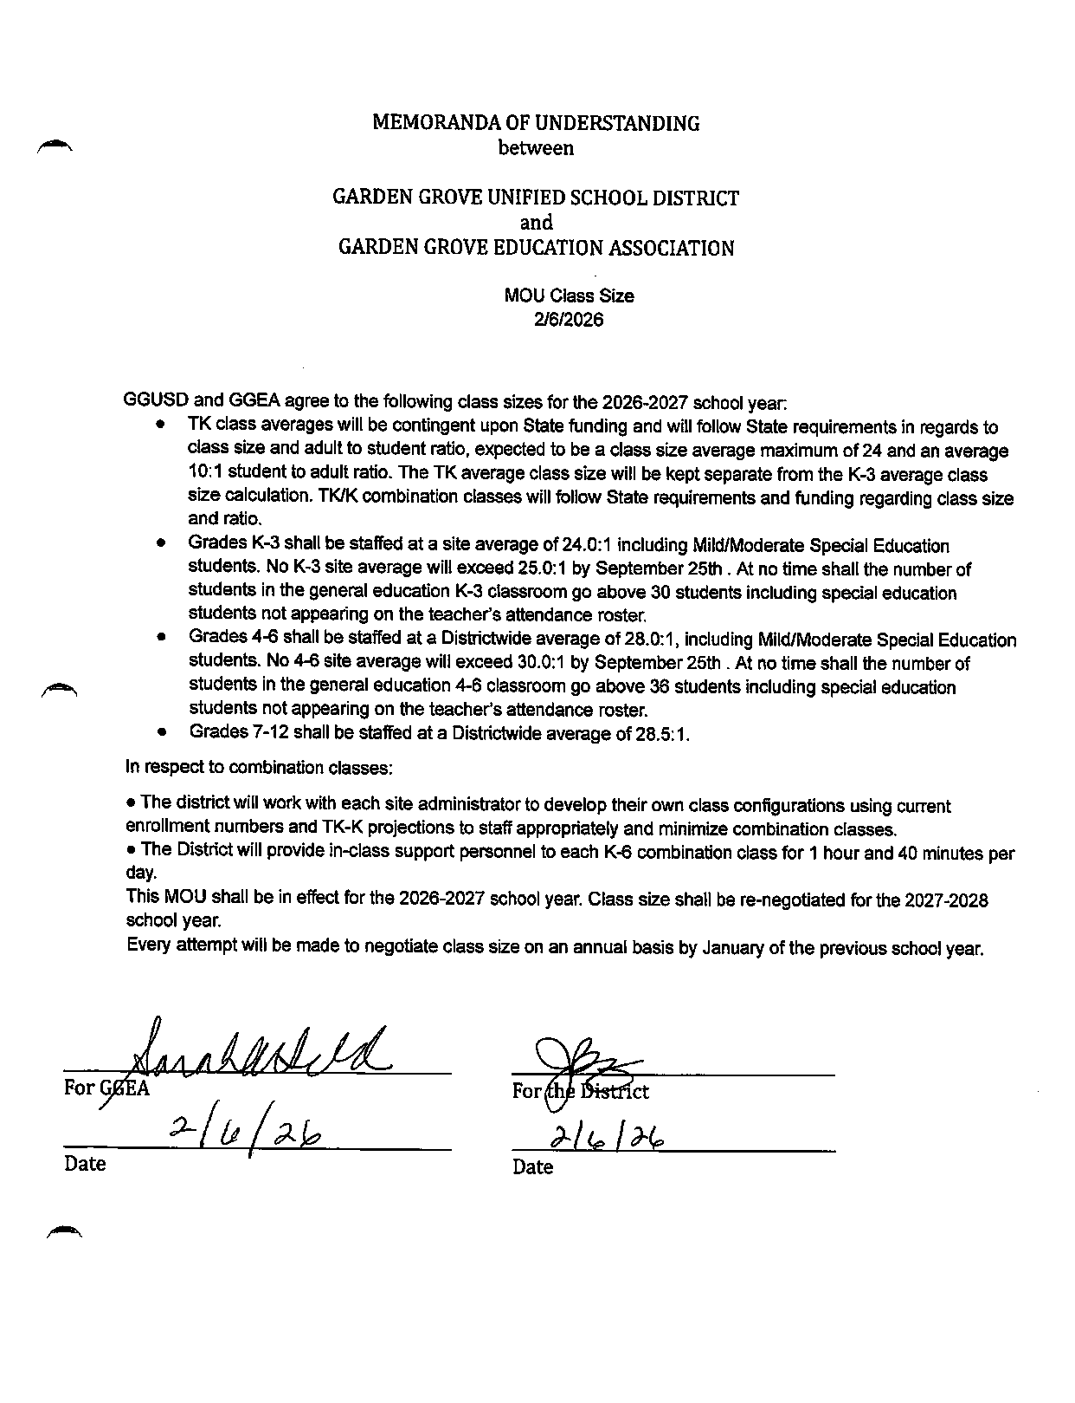

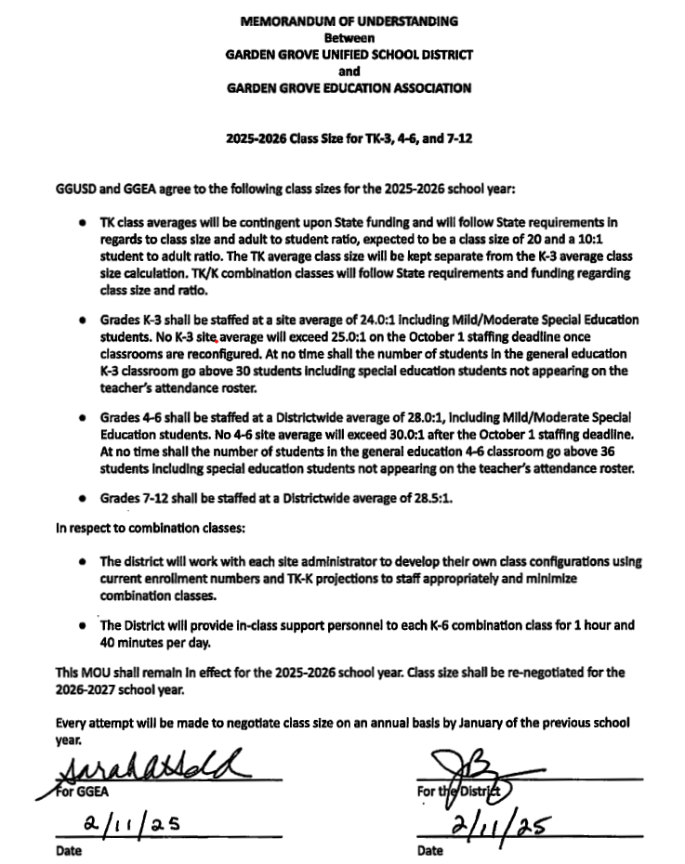

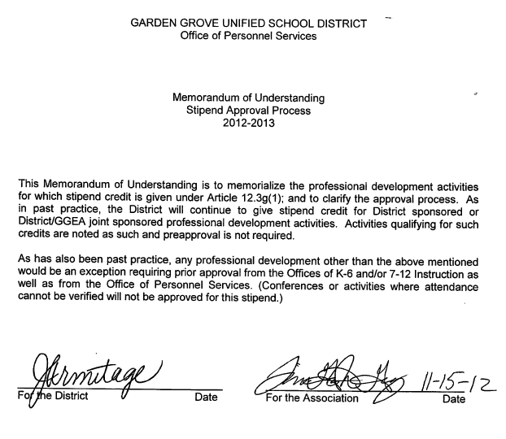

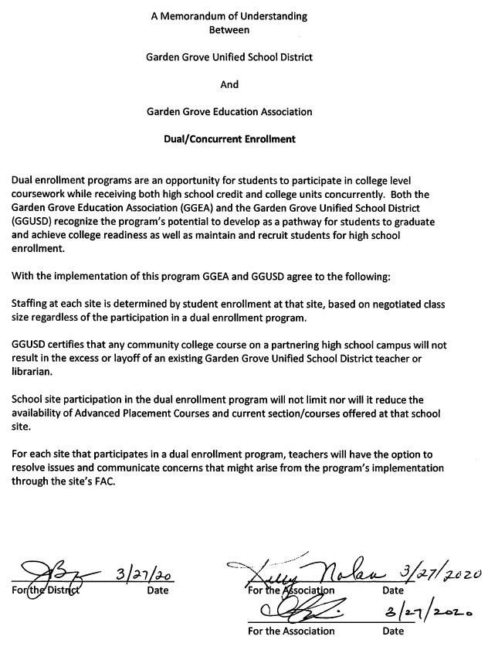

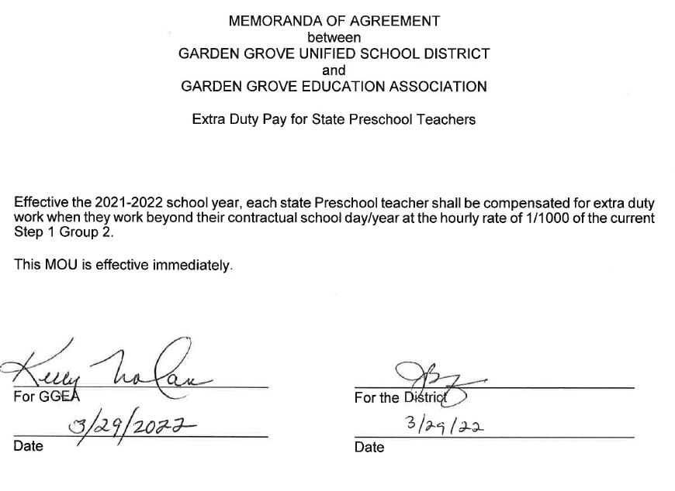

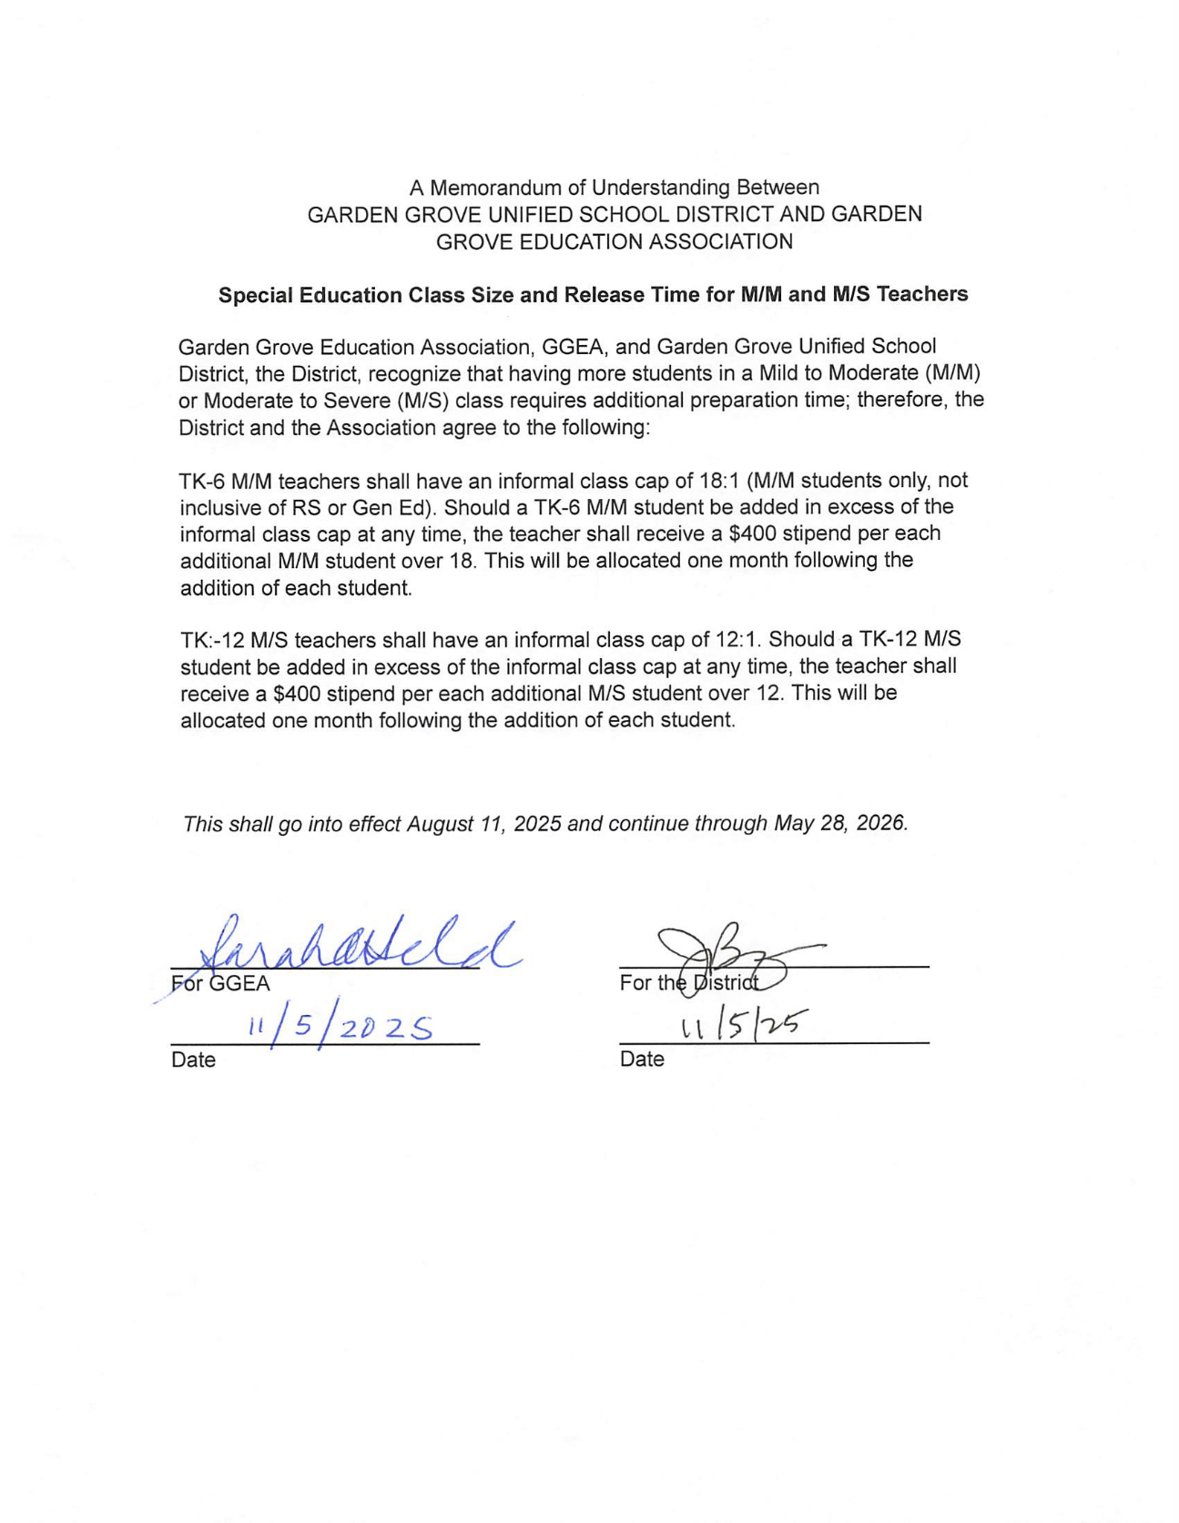

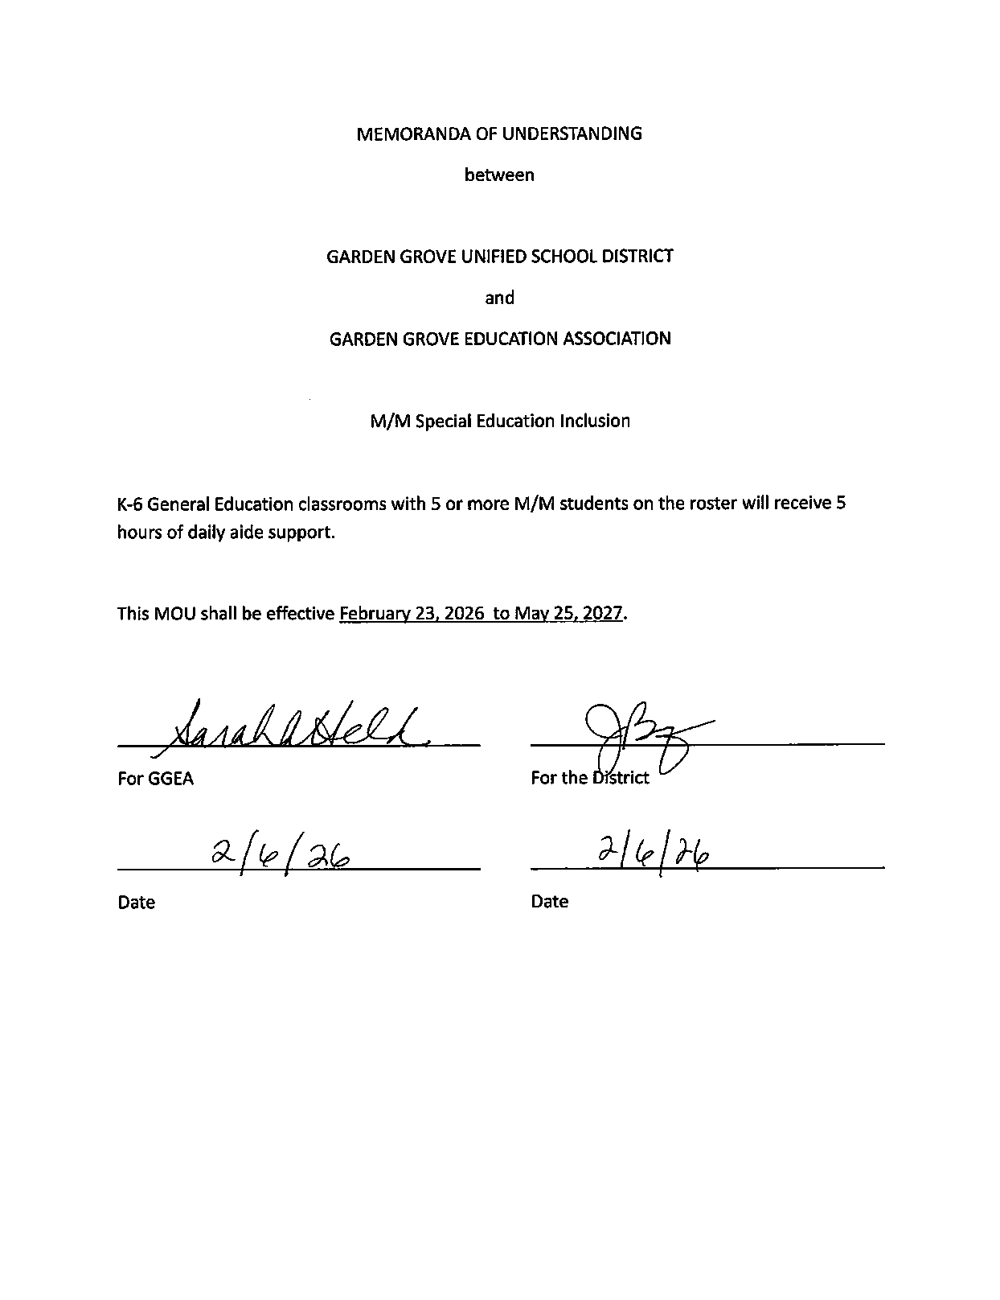

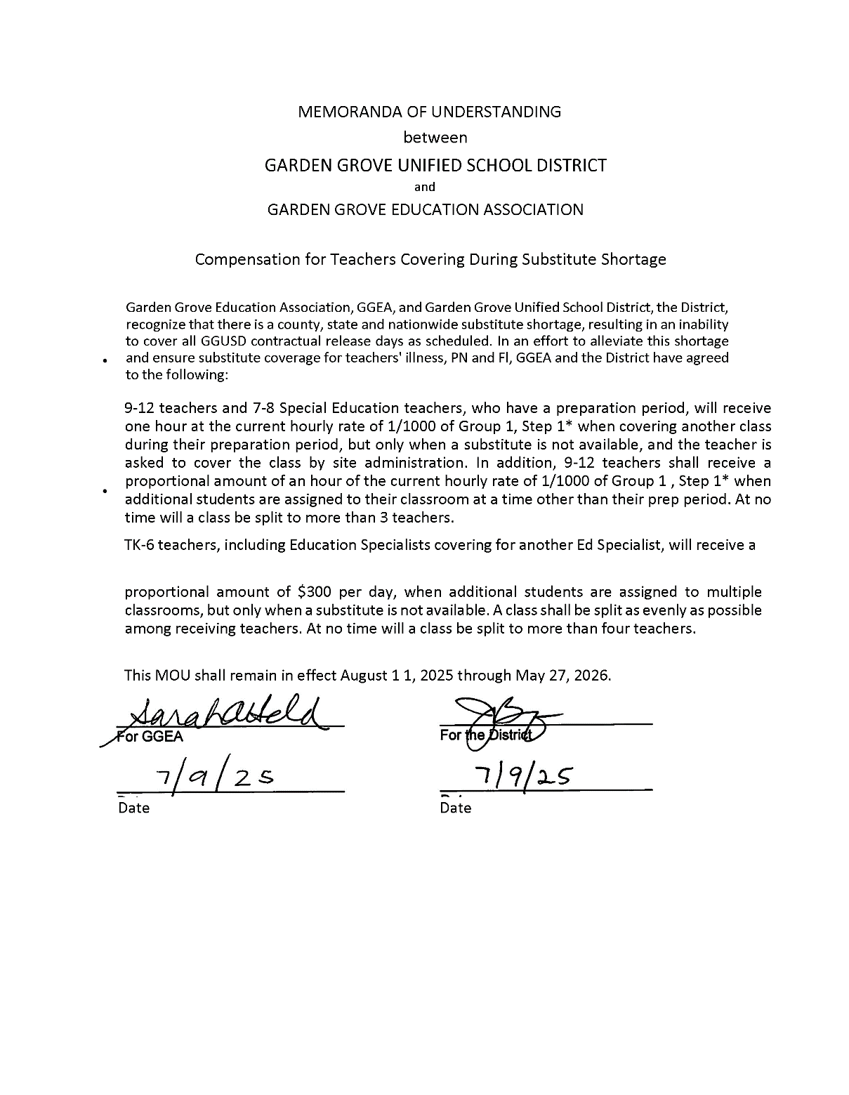

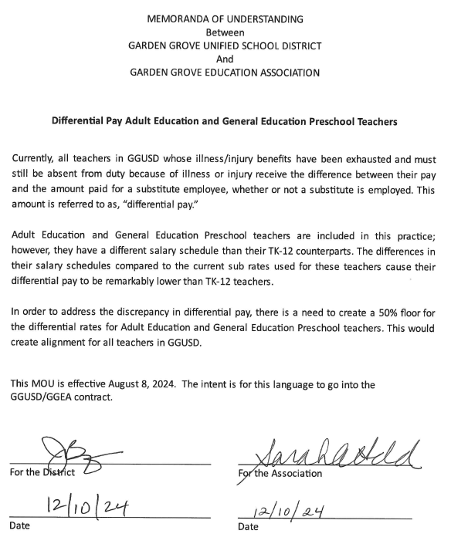

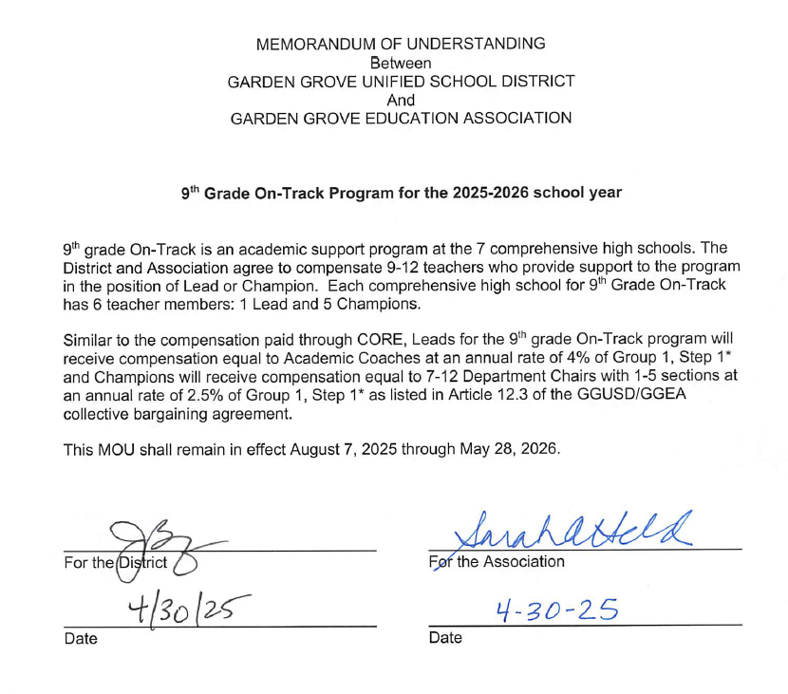

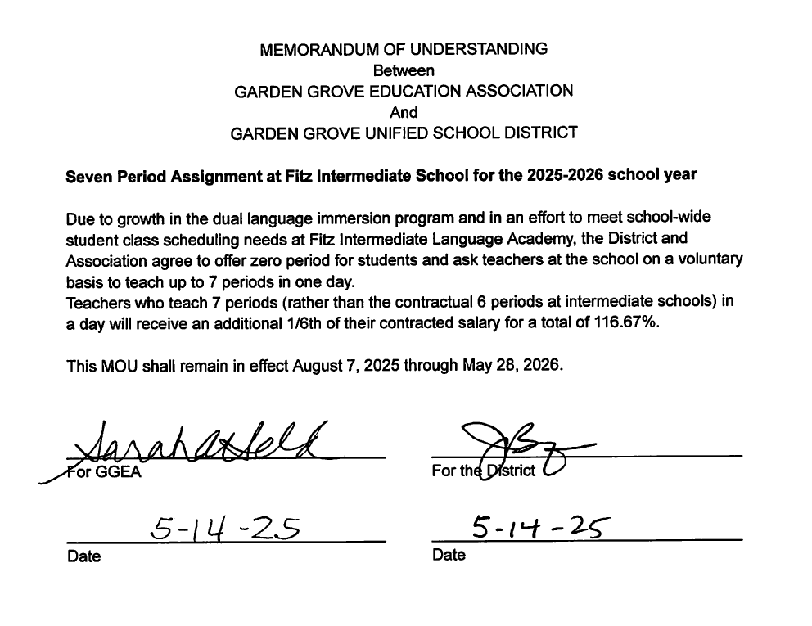
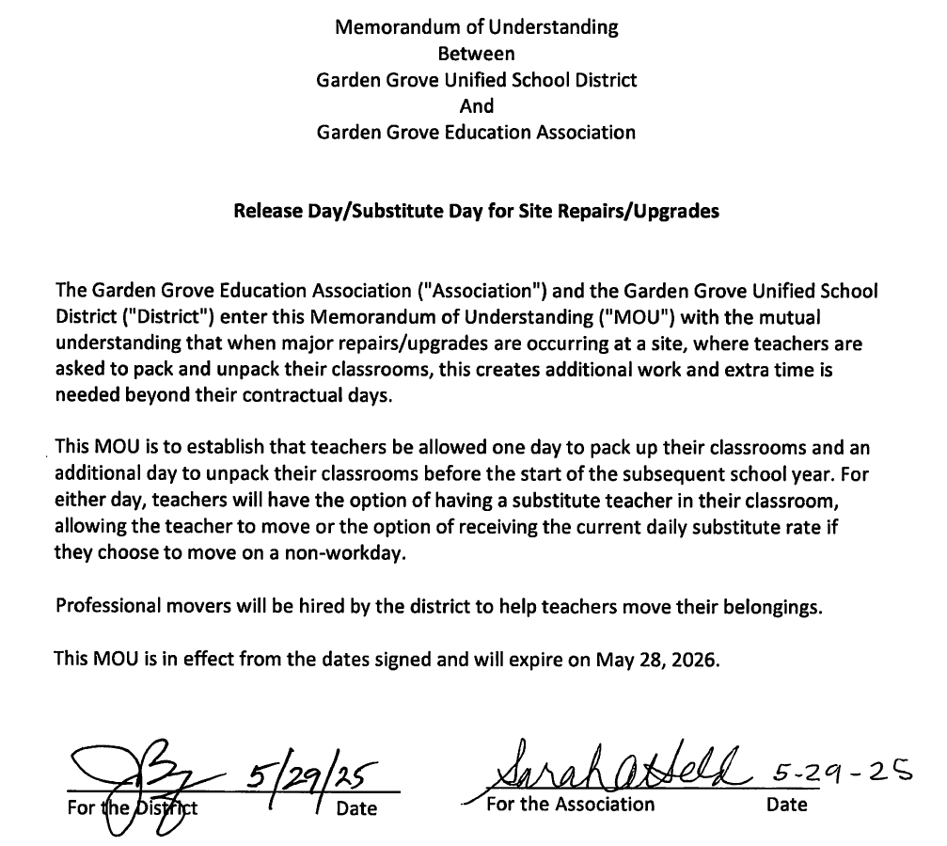

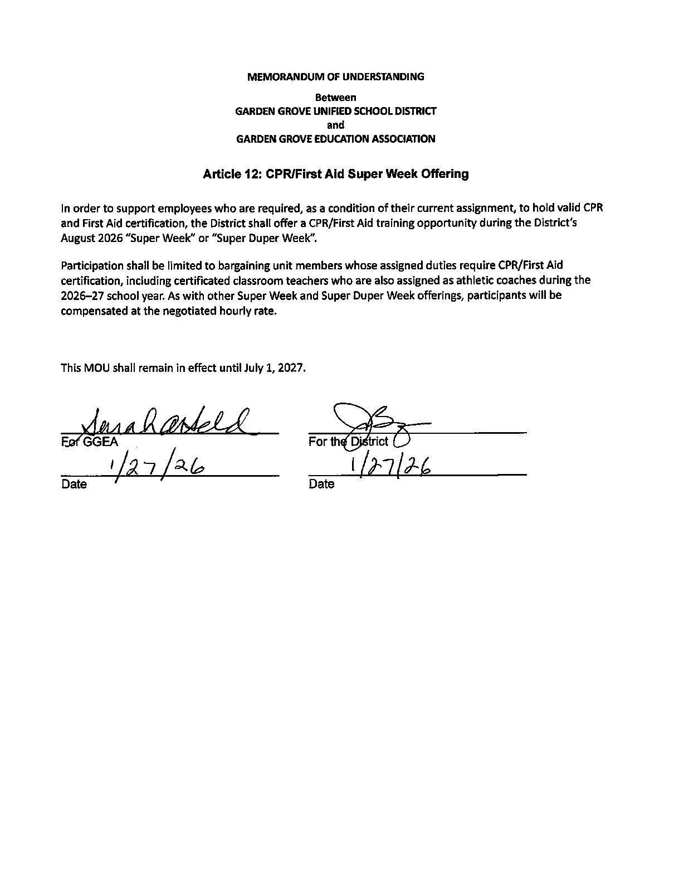

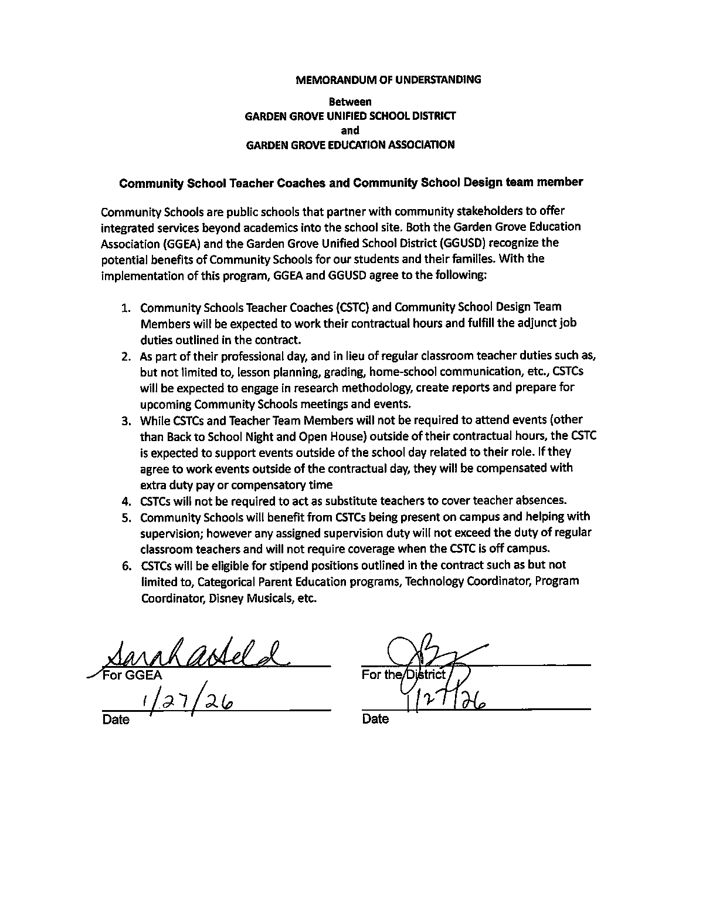
SIDE LETTERS

BETWEEN

GARDEN GROVE UNIFIED SCHOOL DISTRICT

AND

GARDEN GROVE EDUCATAION
ASSOCIATION/CTA/NEA

