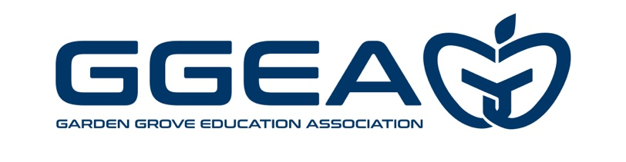
ELECTIONS CALENDAR FOR 2025-26

Election for:
A. GGEA Delegates to NEA National Convention
B. California State Delegates to NEA National Convention (tentative)
January 14 Declaration of Candidacy requested from Membership
January 30 Deadline for turning in Nominations Forms – 5:00 p.m.
February 4 List of candidates to be posted at each site
February 24 NEA Nominations by Rep Council (if necessary); Candidates Speeches
February 26 Preparation of Ballots – 3:30 p.m. – Rules & Elections Committee
March 2-6 Voting/Election
March 6 Deadline for receiving ballots in the GGEA office – 5:00 p.m.
Ballot box will be sealed at 5:00 p.m.
March 9 Count Ballots – 3:30 p.m. – Rules & Elections Committee
March 24 Deadline for filing challenges

Election For:
A. GGEA Board of Directors: President, 2nd Vice President, Secretary, 1 High School Director, 1 Intermediate Director, and 2 Elementary Directors
B. GGEA State Council Delegates (according to CTA Representation allocation)
February 25 Declaration of Candidacy requested from Membership
March 9 Deadline for turning in nomination forms 5:00 p.m.
March 10 Segment Director Candidate speeches at respective meetings
March 31 Rep Council – Candidate Speeches (Officers & State Council)
April 3 List of candidates to be posted at each site
April 6 Preparation of Ballots - 3:30 p.m. - Rules & Elections Committee
April 20-24 Voting/Election all week
April 24 Deadline for receiving ballots in the GGEA office – 5:00 p.m.
Ballot box will be sealed at 5:00 p.m.
April 27 Count Ballots – 3:30 p.m. – Rules and Elections Committee
May 11 Deadline for filing challenges

If a run-off election is necessary, it will be held August 2026

Election For:
- Education Action Committee (EAC) Members
May 1 Declaration of Candidacy requested from Membership
May 15 Deadline for turning in declaration forms 5:00 p.m.
May 19 Election at Rep Council

